CSS BRITISH HISTORY · TOPIC 5 · KNOWLEDGE BASE
The Age of Reform, Parties, Peel, Gladstone and Ireland (1815–1928)
How Britain reformed its Parliament, built its modern parties, and struggled with Ireland — Liverpool, Peel, the Reform Acts, Gladstone, Disraeli and Home Rule, with the story carried on to 2026

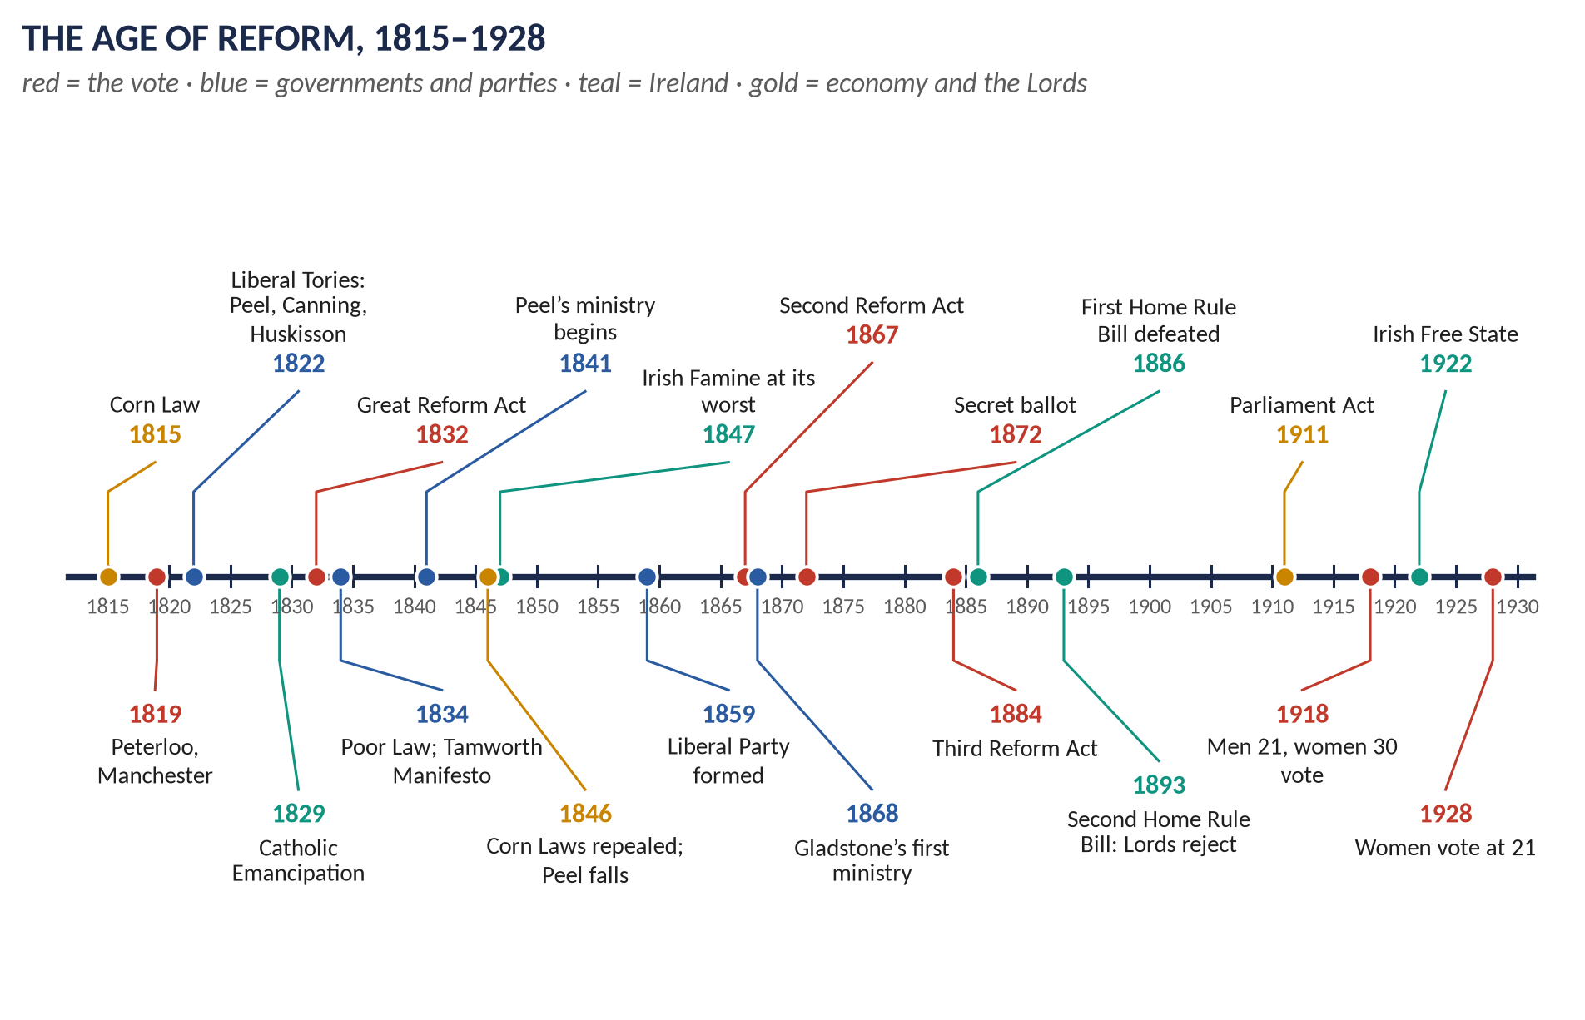
Syllabus heads VIII and IX. 12 full questions in 2015–2026 and 7 MCQs — the most-asked topic in Section A by full questions: parliamentary reform 5 times, Peel 3, Gladstone 2, the Irish Question and party politics once each. Told from zero, then eight chapters, 120 one-liners and a stand-alone revision sheet.
Topic 5 of 10 · read with the companion document T5QA
Contents
HOW TO USE THIS · Updating the contents
Right-click the contents → Update Field → Update entire table, before saving as PDF.

How to Use This Document 5
What this Topic covers 5
Part Zero — The ABC Before the Story 6
0.1 How Britain was governed in 1815 — the simple picture 6
0.2 Who elected the MPs — and why that was a problem 6
0.3 The words you need 7
Part One — The Story 9
1.1 After Waterloo: hard times and fear (1815–1822) 9
1.2 The "liberal Tories" (1822–1830) 9
1.3 The Great Reform Act (1830–1832) 9
1.4 The reforming Whigs and William IV (1830–1837) 9
1.5 Sir Robert Peel (1834–1846) 10
1.6 New parties and the second step (1846–1867) 10
1.7 Gladstone and Disraeli (1868–1894) 10
1.8 The Irish Question and Home Rule (1886–1922) 10
1.9 Completing democracy (1911–1928) — and after 11
Part Two — The Cast and the Time-line 12
2.1 The cast 12
2.2 The time-line 13
Part Three — The Chapters 14
Chapter 1 · Tory Britain, 1815–1830: From Repression to Liberal Toryism 15
1.1 Lord Liverpool's government 15
1.2 The years of repression (1815–1820) 15
1.3 Liberal Toryism (1822–1827) 15
(i) Robert Peel at the Home Office (1822–27, 1828–30) 15
(ii) William Huskisson at the Board of Trade (1823–27) 16
(iii) Other reforms 16
1.4 Canning, Goderich and Wellington (1827–1830) 16
1.5 Two surprising reforms under Wellington 16
(i) Repeal of the Test and Corporation Acts (1828) 16
(ii) Catholic Emancipation (1829) 16
1.6 The fall of the Tories (1830) 17
Chapter 2 · The Great Reform Act, 1832 18
2.1 The case for reform 18
2.2 Why reform came in 1830–32 18
2.3 The crisis — how the Act was passed 18
2.4 What the Act did — the terms 19
(i) Redistribution of seats 19
(ii) The franchise (the vote) 19
(iii) The numbers 19
2.5 Critical analysis — strengths and weaknesses 19
2.6 How 1832 made the next reforms possible 20
Chapter 3 · William IV and the "Era of Bills and Acts", 1830–1837 21
3.1 A short reign, a long list 21
3.2 The Acts, one by one 21
3.3 The constitutional change: the King and his ministers 22
3.4 Why so many Acts in so few years? 22
Chapter 4 · Sir Robert Peel 23
4.1 His life and career 23
4.2 The Tamworth Manifesto (December 1834) 24
4.3 Interior (domestic) policy as Prime Minister, 1841–46 24
(i) Finance and the economy 24
(ii) Social reforms 24
(iii) The repeal of the Corn Laws (1846) 24
4.4 The Irish issue 25
(i) Firmness — the Repeal campaign 25
(ii) Conciliation — "killing Repeal by kindness" 25
(iii) The Great Famine 25
4.5 Exterior (foreign and imperial) policy, 1841–46 26
4.6 Peel's methods of governance — compared with his predecessors 26
4.7 "The most liberal of conservatives and the most conservative of liberals" 27
(i) The liberal Peel 27
(ii) The conservative Peel 27
(iii) Reconciling the two 27
(iv) What others said 28
Chapter 5 · The Road to Democracy, 1832–1928 — and On to 2026 29
5.1 Step by step 29
5.2 Why did Britain become a democracy? — the forces behind each step 30
(i) Pressure from outside Parliament 30
(ii) Rivalry between the parties 30
(iii) Economic and social change 30
(iv) Liberal ideas 30
(v) War 31
5.3 Critical examination — how democratic, and how quickly? 31
5.4 After 1928 — the story to 2026 31
Chapter 6 · The Evolution of Party Politics in the 19th Century 32
6.1 What a party was in 1815 32
6.2 Stage 1 · 1832–1846: the birth of modern parties 32
6.3 Stage 2 · 1846–1867: fluid parties 33
6.4 Stage 3 · 1867–1886: mass parties 33
(i) The Conservatives 33
(ii) The Liberals 33
6.5 Stage 4 · 1886–1900: realignment 33
6.6 Disraeli and "Tory democracy" 33
6.7 The changing relationship between government, Parliament and the electorate 34
Chapter 7 · Gladstone's Domestic Policy — the Climax of Liberalism? 35
7.1 Who was Gladstone? 35
7.2 What was nineteenth-century liberalism? 35
7.3 Gladstone as Chancellor — the financial foundations 36
7.4 The first ministry (1868–74) — "the great ministry" 36
7.5 The second ministry (1880–85) 37
7.6 The third and fourth ministries (1886, 1892–94) 37
7.7 Was it "the climax of liberalism"? 37
(i) Yes 37
(ii) But 37
Chapter 8 · The Irish Question 38
8.1 Defining the Irish Question 38
8.2 From the Union to 1885 38
8.3 The Liberal policy, 1886–1894 39
(i) The First Home Rule Bill (April 1886) 39
(ii) The Liberal split and the Unionist years (1886–92) 39
(iii) The Second Home Rule Bill (1893) 39
8.4 Assessment of the Liberal policy 39
8.5 What happened next — to 2026 40
Part Four — Historians and Quotations 41
Part Five — The Examiner's Record 42
Part Six — The One-Liner Bank 43
One-liners · Tory Britain, 1815–1830 43
One-liners · The Great Reform Act and William IV 43
One-liners · Sir Robert Peel 44
One-liners · Reform to democracy, 1832–1928 and after 45
One-liners · Parties and Disraeli 46
One-liners · Gladstone and Ireland 47
Part Seven — Revision Sheet · Topic 5: The Age of Reform, Parties, Peel, Gladstone and Ireland 48
R5.1 The topic in one paragraph 48
R5.2 Tory Britain 1815–30 48
R5.3 The Great Reform Act 1832 48
R5.4 William IV's "era of bills and acts" (1830–37) 49
R5.5 Peel 49
R5.6 The road to democracy 49
R5.7 Parties 49
R5.8 Gladstone's domestic policy 50
R5.9 The Irish Question 50

How to Use This Document

What this Topic covers
Topic 5 is the story of how Britain became a democracy without a revolution. It runs from 1815, when the long wars with France ended, to 1928, when every adult woman finally got the vote — and, in short notes, on to 2026. It covers syllabus Head VIII (the reform of Parliament; Peel) and Head IX (Gladstone; the Irish Question; party politics).
WHAT THE EXAMINER HAS ASKED · Why this topic matters
12 full questions in 2015–2026 — more than any other topic — plus 7 MCQs. Five questions are on parliamentary reform (2015, 2016, 2018, 2019, 2020), three on Sir Robert Peel (2018, 2020, 2024), two identical ones on Gladstone's domestic policy (2017, 2022), one on the Irish Question (2024) and one on party politics (2025). In an average year at least one Section A question comes from this topic.

THE STORY IN SIMPLE WORDS · Where this topic fits in the story
Topic 3 ended with the defeat of Napoleon at Waterloo (1815). Topic 4 told the story of the Industrial Revolution — the new towns, the new middle and working classes. Topic 5 tells what those new classes did politically: they demanded a voice in Parliament, and slowly, step by step, they got it. Topic 6 covers Victorian foreign policy in the same years; Topic 7 carries the story into the twentieth century.

Part Zero — The ABC Before the Story

0.1 How Britain was governed in 1815 — the simple picture
Think of the British system as three parts that must all agree before a law is made:
1. The Crown — the King or Queen. In 1815 the monarch still chose the ministers and could dismiss them.
2. The House of Lords — the "upper house": about 350 peers (dukes, earls, lords — who inherited their seats) and bishops of the Church of England. Nobody elected them.
3. The House of Commons — the "lower house": 658 MPs (Members of Parliament), elected — but by very few people.
The Prime Minister (PM) is the leader of the government. He chooses the Cabinet — the top ministers who run the departments (the Treasury, the Home Office, the Foreign Office and so on). To stay in power the government needs the support of the Commons.

0.2 Who elected the MPs — and why that was a problem
- Britain was divided into constituencies — areas that elect MPs. There were two kinds: counties (the countryside) and boroughs (towns).
- In 1815 only about one adult man in ten could vote — around 500,000 people in a population of about 16 million (UK, 1831 census: 24 million). No women could vote.
- Voting was open: you called out your choice in public, so your landlord or employer knew how you voted. Bribery was common.
- The map of constituencies had hardly changed since the Middle Ages. Some boroughs had almost no people:
  - Old Sarum, an empty hill, elected two MPs.
  - Dunwich had mostly fallen into the sea but still elected two MPs.
  - Such places were called rotten boroughs. Boroughs controlled by one great landowner were called pocket boroughs — he had them "in his pocket".
- Meanwhile great new industrial towns — Manchester, Birmingham, Leeds, Sheffield — had no MPs of their own at all.
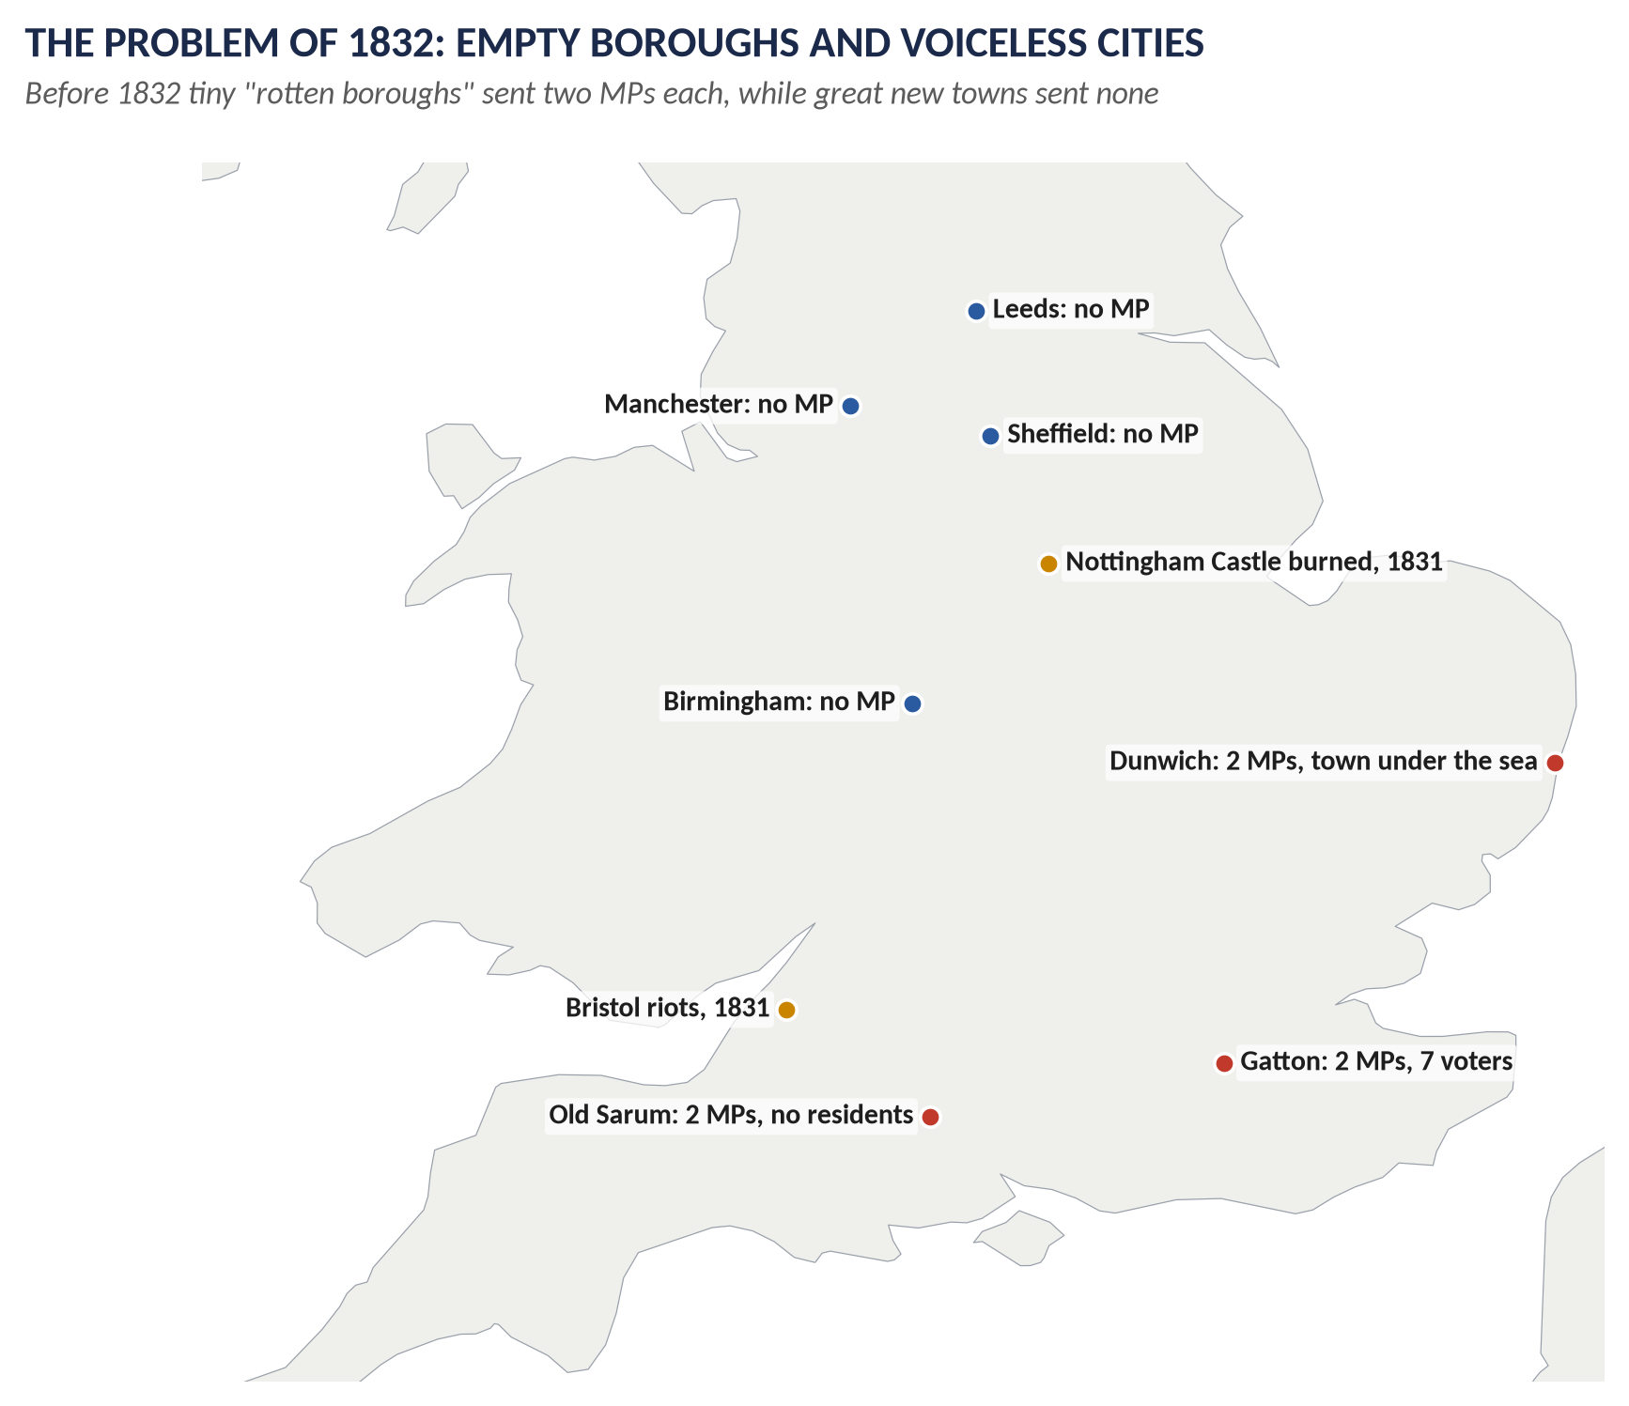
Figure 1 · The problem before 1832: empty boroughs with two MPs each, great cities with none.

0.3 The words you need
Word | What it means, simply
Franchise | The right to vote. "Extending the franchise" = giving more people the vote.
Electorate | All the people who have the vote.
Constituency | An area that elects an MP.
Borough / County | A town constituency / a countryside constituency.
Rotten borough | A borough with almost no voters that still elected MPs.
Pocket borough | A borough controlled by one landowner, who chose its MPs.
Redistribution | Taking MPs away from small places and giving them to big ones.
Secret ballot | Voting privately on paper, so no one knows your choice.
Tory / Conservative | The party of the Crown, the Church of England and landowners; called "Conservative" from the 1830s.
Whig / Liberal | The party of reform and liberty; the Whigs joined Radicals and Peelites to form the Liberal Party in 1859.
Radical | Someone who wanted big, rapid reform — for example votes for all men.
Corn Laws | Laws (1815) keeping out cheap foreign corn to protect British farmers' prices.
Free trade | Trading with no or low taxes on imports and exports. Its opposite is protection.
Laissez-faire | "Let it be": the idea that government should interfere as little as possible.
Manifesto | A public statement of what a party will do if elected.
Catholic Emancipation | Allowing Roman Catholics to sit in Parliament and hold high office (1829).
Home Rule | A parliament in Dublin to run Ireland's own affairs, while Ireland stayed in the United Kingdom.
Irish Question | The long problem of how to govern Ireland — its land, its religion and its demand for self-government.
Democracy | Government chosen by the people: every adult has an equal vote, cast freely and secretly.

KEY IDEA · The one idea to hold on to
In 1815 Britain was ruled by a small class of landowners, chosen by a tiny electorate. By 1928 every adult man and woman had an equal, secret vote, and the Commons — not the Crown or the Lords — was supreme. This topic explains how that happened, step by step, and who made it happen.

Part One — The Story
THE STORY IN SIMPLE WORDS · The story in simple words
Read this Part first, straight through, like a story. The details, figures and arguments come in the chapters.

1.1 After Waterloo: hard times and fear (1815–1822)
When the wars with France ended in 1815, Britain faced hard times. Soldiers came home to no jobs; factories cut wages. The Tory government of Lord Liverpool (Prime Minister 1812–27) passed a Corn Law (1815) that kept out foreign corn until British prices were very high — good for landowners, bad for the hungry poor. Working people held huge meetings calling for parliamentary reform. The government, remembering the French Revolution, was afraid. On 16 August 1819, soldiers charged a peaceful crowd of about 60,000 at St Peter's Fields, Manchester, killing about 15 people and injuring hundreds. People called it "Peterloo" — a bitter joke on Waterloo. The government replied with the Six Acts (1819), which restricted meetings and newspapers.

1.2 The "liberal Tories" (1822–1830)
From 1822 Liverpool brought in younger, more open-minded ministers: George Canning at the Foreign Office, Robert Peel at the Home Office, William Huskisson at the Board of Trade. They reformed the criminal law, cut trade taxes and allowed trade unions (1824). After Liverpool fell ill in 1827, Canning (1827) and then the Duke of Wellington (1828–30), the victor of Waterloo, became Prime Minister. Wellington and Peel, facing a possible civil war in Ireland, passed Catholic Emancipation (1829), letting Catholics sit in Parliament. But Wellington flatly refused any reform of Parliament — and in November 1830 his government fell.

1.3 The Great Reform Act (1830–1832)
The new Whig Prime Minister, Earl Grey, introduced a Reform Bill. It took three attempts, a general election, riots in Bristol, Nottingham and Derby, and a threat by King William IV to create enough new Whig peers to outvote the Lords, before the Reform Act became law on 7 June 1832. It abolished the rotten boroughs, gave MPs to the new towns, and gave the vote to middle-class men. It was a small step — still only about one man in five could vote — but it broke the old system.

1.4 The reforming Whigs and William IV (1830–1837)
The short reign of William IV (1830–37) saw a flood of new laws: the abolition of slavery in the empire (1833), the first effective Factory Act (1833), a New Poor Law (1834), elected town councils (1835), and the registration of births, marriages and deaths (1836). In 1834 William IV dismissed his Whig Prime Minister, Lord Melbourne — the last time a monarch has ever done so.

1.5 Sir Robert Peel (1834–1846)
Peel led the Tories back to power. In his Tamworth Manifesto (1834) he accepted the Reform Act and promised careful reform: the Tories became the Conservative Party. As Prime Minister (1841–46) he brought back the income tax, cut import taxes, reformed banking, and passed laws on mines and factories. When the potato famine struck Ireland in 1845, he decided that cheap food mattered more than protecting landowners, and he repealed the Corn Laws (1846). Two-thirds of his own party voted against him, led by Benjamin Disraeli. The Conservatives split, and Peel's government fell. He died in 1850.

1.6 New parties and the second step (1846–1867)
For twenty years parties were fluid. The Peelites (Peel's followers, including William Gladstone) joined the Whigs and Radicals, and in 1859 they formed the Liberal Party, led first by Lord Palmerston. After Palmerston died (1865), pressure for reform returned. In 1867 the Conservative Disraeli passed the Second Reform Act, which gave the vote to skilled working men in the towns — and roughly doubled the electorate.

1.7 Gladstone and Disraeli (1868–1894)
Two great rivals now dominated politics. Gladstone, the Liberal, was Prime Minister four times (1868–74, 1880–85, 1886, 1892–94). His first ministry reformed almost every institution: schools (1870), the civil service (1870), the army (1871), the universities (1871), the secret ballot (1872). Disraeli, the Conservative (PM 1868 and 1874–80), passed social reforms on housing, public health and trade unions. Gladstone's second ministry gave the vote to working men in the countryside (1884).

1.8 The Irish Question and Home Rule (1886–1922)
Ireland had been joined to Britain by the Act of Union (1801, Topic 3). Its people were mostly Catholic, mostly poor tenant farmers, and many wanted their own parliament. The Great Famine (1845–49) killed about a million and drove another million abroad. Gladstone tried to "pacify Ireland" with reforms, and in 1886 introduced a Home Rule Bill. It split his party and was defeated; a second bill (1893) was thrown out by the Lords. Home Rule finally passed in 1914, but the First World War, the Easter Rising (1916) and a war of independence followed; in 1922 southern Ireland became the Irish Free State, while Northern Ireland stayed in the UK.

1.9 Completing democracy (1911–1928) — and after
The Parliament Act (1911) ended the Lords' power to block laws passed by the Commons. The same year MPs began to be paid. In 1918 all men over 21 and women over 30 got the vote; in 1928 women got the vote at 21, on equal terms with men. Britain had become a democracy.
VERDICT · The story in one sentence
Between 1815 and 1928 pressure from outside Parliament and rivalry between the parties inside it turned a Parliament of landowners chosen by half a million men into a democracy of every adult — while the Irish Question, which none of the great leaders could solve, ended with most of Ireland leaving the United Kingdom.

Part Two — The Cast and the Time-line

2.1 The cast
Person | Dates / office | Who they were — in one line
Lord Liverpool | PM 1812–27 | Tory PM for 15 years; repression after 1815, then "liberal Toryism".
George Canning | PM 1827 | Brilliant liberal Tory foreign secretary; PM for 119 days before he died.
Duke of Wellington | PM 1828–30 | Victor of Waterloo; passed Catholic Emancipation; refused parliamentary reform.
William IV | King 1830–37 | The "Sailor King"; agreed to create peers to pass the Reform Act; dismissed Melbourne (1834).
Earl Grey | PM 1830–34 | Whig leader who passed the Great Reform Act (1832).
Lord Melbourne | PM 1834, 1835–41 | Whig PM; mentor of the young Queen Victoria.
Daniel O'Connell | 1775–1847 | "The Liberator": won Catholic Emancipation; led the campaign to repeal the Union.
Sir Robert Peel | PM 1834–35, 1841–46 | Founder of the Conservative Party and the police; repealed the Corn Laws.
Lord Aberdeen | Foreign Sec. 1841–46 | Peel's peaceful foreign secretary; later PM (1852–55).
Queen Victoria | 1837–1901 | Longest-reigning monarch of the House of Hanover (63 years).
Lord Palmerston | PM 1855–58, 1859–65 | First leader of the Liberal Party; better known for foreign policy (Topic 6).
Benjamin Disraeli | PM 1868, 1874–80 | Conservative leader; destroyed Peel in 1846; passed the Second Reform Act (1867); "Tory democracy".
William Ewart Gladstone | PM 1868–74, 1880–85, 1886, 1892–94 | The "Grand Old Man" of Liberalism; great reformer; champion of Irish Home Rule.
Charles Stewart Parnell | 1846–91 | Leader of the Irish Home Rule Party; "the uncrowned king of Ireland".
Joseph Chamberlain | 1836–1914 | Radical Liberal from Birmingham; left the Liberals over Home Rule (1886).
Lord Salisbury | PM 1885–86, 1886–92, 1895–1902 | Conservative leader who gained most from the Liberal split.
Emmeline Pankhurst | 1858–1928 | Leader of the suffragettes (WSPU, 1903); died weeks after the 1928 Act.

2.2 The time-line
Figure 2 · The Age of Reform, 1815–1928.

Part Three — The Chapters

Chapter 1 · Tory Britain, 1815–1830: From Repression to Liberal Toryism

1.1 Lord Liverpool's government
Lord Liverpool was Prime Minister for 15 years (1812–27) — longer than anyone since. He was not brilliant, but he was a skilful manager: he held together a cabinet of rigid "Ultra" Tories and open-minded "liberal" Tories, and kept the support of the King and the Commons.

1.2 The years of repression (1815–1820)
Year | Event — and what it means
1815 | Corn Law: no foreign wheat could be imported until the British price reached 80 shillings a quarter. Landowners gained; bread stayed dear.
1816 | Income tax abolished (it had been a wartime tax); the loss was made up by taxes on goods, which hit the poor. Spa Fields meetings in London.
1817 | Habeas Corpus suspended — the government could imprison people without trial. The Blanketeers' march from Manchester and the Pentrich Rising in Derbyshire.
1819 | Peterloo (16 August): cavalry attacked a reform meeting of about 60,000 addressed by Henry "Orator" Hunt at St Peter's Fields, Manchester; about 15 killed, 400–700 injured. Then the Six Acts: limits on meetings, heavy stamp duty on newspapers, searches for weapons.
1820 | Cato Street Conspiracy: a plot to murder the whole cabinet; its leaders were hanged.

WHY THIS ANSWER SCORES · Why was the government so harsh?
The ministers had lived through the French Revolution and the Terror. They feared that mass meetings of hungry workers were the first step to revolution in Britain. They had no police force — only soldiers — so every riot seemed dangerous.

1.3 Liberal Toryism (1822–1827)
In 1822 the Foreign Secretary Castlereagh killed himself, and Liverpool reshuffled his cabinet, bringing in a group of reformers:

(i) Robert Peel at the Home Office (1822–27, 1828–30)
- Removed the death penalty for over 100 crimes (once a person could be hanged for stealing goods worth five shillings).
- Gaols Act (1823): prisons inspected; jailers paid; women warders for women prisoners.
- Metropolitan Police Act (1829): the first professional police force in London — called "Bobbies" or "Peelers" after him.

(ii) William Huskisson at the Board of Trade (1823–27)
- Reduced import duties on many goods (silk, wool, iron, coffee).
- Reciprocity of Duties Act (1823): lower duties with countries that did the same for Britain.
- Relaxed the old Navigation Acts.
- Sliding scale for the Corn Law (1828): the duty fell as the price rose.

(iii) Other reforms
- Combination Acts repealed (1824): trade unions became legal (restricted again in 1825).
- George Canning at the Foreign Office recognised the new Latin American republics — a liberal foreign policy (Topic 6).
KEY IDEA · Why "liberal Toryism" matters
It showed that the Tories themselves could reform. Peel learned his trade here; much of what he did as Prime Minister in the 1840s continued the work of the 1820s.

1.4 Canning, Goderich and Wellington (1827–1830)
- Canning became PM in April 1827 but died in August — after only 119 days.
- Lord Goderich (1827–28) could not hold the government together.
- The Duke of Wellington (1828–30), a soldier with no taste for compromise, then took office with Peel as leader in the Commons.

1.5 Two surprising reforms under Wellington

(i) Repeal of the Test and Corporation Acts (1828)
Protestant Nonconformists (Methodists, Baptists and others) could now legally hold public office.

(ii) Catholic Emancipation (1829)
- The problem: Roman Catholics could vote in Ireland but could not sit in Parliament or hold high office.
- The crisis: in 1828 Daniel O'Connell, leader of the Catholic Association, was elected MP for County Clare — but as a Catholic he could not take his seat. Ireland was close to rebellion.
- The decision: Wellington and Peel, although they had always opposed emancipation, decided that refusing it meant civil war. The Catholic Relief Act (1829) let Catholics sit in Parliament and hold most offices.
- The price: the Irish county vote was restricted (the "40-shilling freeholders" lost it); Tory "Ultras" never forgave Wellington and Peel for their "betrayal".

1.6 The fall of the Tories (1830)
In 1830 King George IV died, a revolution overthrew the King of France, and bad harvests brought distress and the Swing Riots. In November 1830 Wellington told the Lords that the existing system was perfect and he would resist any reform. Within days his government was defeated and the Whigs, under Earl Grey, took office for the first time in almost fifty years.

Chapter 2 · The Great Reform Act, 1832

2.1 The case for reform
1. Unfair distribution of seats: rotten boroughs like Old Sarum (no inhabitants) and Gatton (7 voters) elected two MPs each; Manchester, Birmingham, Leeds and Sheffield elected none. The small counties and boroughs of the south outweighed the growing north.
2. A narrow and confused franchise: about 500,000 voters in the UK; in the boroughs, voting rights varied wildly — from almost every man (Preston) to a handful of officials.
3. Corruption: open voting, bribery, landlords' control.
4. New classes: the industrial middle class paid taxes and created wealth but had little voice.

2.2 Why reform came in 1830–32
- Economic distress (1829–30) and the Swing Riots in the countryside.
- The July Revolution in France (1830) — a reminder of what might happen.
- Political Unions, led by Thomas Attwood's Birmingham Political Union (1830), organised middle- and working-class pressure.
- Wellington's refusal to consider any reform brought down the Tories.
- The Whigs under Grey believed that a limited reform would attach the middle classes to the constitution and so prevent revolution — "reform to preserve".

2.3 The crisis — how the Act was passed
Date | Event
March 1831 | First Reform Bill passes its second reading in the Commons by one vote (302–301), then is defeated in committee.
April–May 1831 | Grey calls a general election on the single issue of reform — and wins a big majority.
October 1831 | The second bill passes the Commons but the Lords reject it. Riots: Bristol (the centre burned; about a dozen killed), Nottingham (the castle burned), Derby.
Early 1832 | A third bill passes the Commons; the Lords try to wreck it with amendments.
May 1832 | "The Days of May": the King refuses to create peers; Grey resigns; Wellington tries and fails to form a government; people talk of a run on the banks ("To stop the Duke, go for gold").
June 1832 | William IV agrees to create enough new peers; the Lords give way. Royal Assent: 7 June 1832. Separate Acts for Scotland and Ireland follow.

2.4 What the Act did — the terms

(i) Redistribution of seats
- 56 boroughs (the smallest) lost both their MPs.
- 30 boroughs lost one of their two MPs.
- 143 seats were redistributed: 22 large towns (including Manchester, Birmingham, Leeds, Sheffield) got two MPs each; about 20 got one; the counties got 65 extra seats.

(ii) The franchise (the vote)
- Boroughs: a single uniform vote for men who owned or rented a house worth £10 a year (the "£10 householders") — mostly the middle class.
- Counties: the old 40-shilling freeholders kept their vote; added were £10 copyholders and leaseholders, and — through the Chandos clause — £50 tenants-at-will (tenants who could be evicted at any time, and so usually voted as their landlord told them).
- Registration: voters had to register — which pushed parties to organise.

(iii) The numbers
- England and Wales: about 366,000 → 652,000 voters.
- UK: about 500,000 → 813,000 — roughly one adult man in five (from about one in ten).
- Scotland: from about 4,500 to about 65,000 — a real revolution there.

2.5 Critical analysis — strengths and weaknesses
Strengths (what it achieved) | Weaknesses (what it did not do)
Broke the old system: the worst rotten boroughs vanished | Four men in five still had no vote; no women at all
Gave MPs to the industrial towns and the vote to the middle class | No secret ballot: intimidation and bribery continued
Proved that the constitution could be changed peacefully by law | Constituencies still very unequal in size
Weakened the Lords and the Crown — the Lords gave way under threat | Landowners still dominated Parliament and the cabinet for decades
Led to voter registration and modern party organisation | Some working men actually lost their vote (e.g. in Preston)
Opened the way to a flood of reforms (1833–36) | Workers felt betrayed → Chartism (1838)

KEY IDEA · The judgement historians make
Norman Gash stressed continuity: after 1832 Parliament looked much as before. But almost all historians agree that the Act's real importance was psychological and constitutional: it showed that the system could be reformed, and once reformed it could be reformed again. The Whigs meant it as a final settlement; it became the first step.

2.6 How 1832 made the next reforms possible
The reformed Parliament was more open to the new towns, to Nonconformists and to middle-class opinion — and it passed a stream of political and administrative reforms:
Area | Reforms that followed
Political | Further Reform Acts (1867, 1884–85, 1918, 1928); the secret ballot (1872); modern party organisation; Tamworth Manifesto (1834)
Administrative (1830s) | Factory inspectors (1833); the Poor Law Commission (1834); elected town councils (1835); civil registration (1836)
Administrative (later) | Public Health Act (1848); civil service entry by examination (1870); Education Act (1870); county councils (1888)
Social | Abolition of slavery (1833); Mines Act (1842); Ten Hours Act (1847)

Each of these created new officials, inspectors and departments — the beginnings of the modern British state.

Chapter 3 · William IV and the "Era of Bills and Acts", 1830–1837

3.1 A short reign, a long list
William IV — the "Sailor King", a younger son of George III who had served in the navy — reigned for only seven years (26 June 1830 – 20 June 1837). Yet those years produced more important laws than any comparable period in the century. The Whigs, in power after almost fifty years, had a big majority in the new reformed Parliament and a long list of reforms waiting.

3.2 The Acts, one by one
Act | Year | What it did, simply
Reform Act | 1832 | Redistributed seats; gave the vote to middle-class men (Chapter 2).
Slavery Abolition Act | 1833 | Abolished slavery in the British Empire from 1 August 1834; about 800,000 enslaved people freed; £20 million compensation paid to the owners; freed people had to work as "apprentices" until 1838. Campaigners: William Wilberforce (died 1833), Thomas Fowell Buxton.
Factory Act | 1833 | No children under 9 in textile mills; ages 9–13 limited to 9 hours a day; four paid inspectors — the first effective factory law.
Education grant | 1833 | The first government money for schools: £20,000 a year to church school societies.
Irish Church Temporalities Act | 1833 | Reduced the number of Protestant bishops in Catholic Ireland.
East India Company Charter Act | 1833 | Ended the Company's trade monopoly with China; the Company became a governing body in India.
Poor Law Amendment Act | 1834 | The New Poor Law: parishes grouped into unions; relief for the able-bodied only inside a workhouse; a central Poor Law Commission. Shaped by Edwin Chadwick and Utilitarian ideas.
Municipal Corporations Act | 1835 | Replaced corrupt, closed town corporations with elected councils chosen by ratepayers — the start of modern local government.
Tithe Commutation Act | 1836 | Replaced the tithe (a tenth of produce paid to the Church) with a money payment.
Marriage Act | 1836 | Nonconformists and Catholics could marry in their own chapels; civil marriage before a registrar.
Births and Deaths Registration Act | 1836 | Civil registration of births, marriages and deaths from 1837 — the state now counted its people.
Newspaper stamp duty cut | 1836 | Reduced from 4d to 1d — cheaper newspapers.

3.3 The constitutional change: the King and his ministers
- 1832: William IV agreed to create peers to pass the Reform Act — the Crown sided with the Commons against the Lords.
- November 1834: William IV dismissed the Whig PM Lord Melbourne and appointed Peel. Peel lost the election of 1835 and resigned after about a hundred days. This was the last time a British monarch dismissed a Prime Minister — and it showed that, after 1832, the voters, not the King, decided who governed.
- 1834–35: Peel's Tamworth Manifesto; the Lichfield House Compact (1835) between Whigs, Radicals and O'Connell's Irish MPs — early signs of modern party politics.

3.4 Why so many Acts in so few years?
1. The Whigs in power with a large majority after 1832.
2. The reformed Parliament was more open to middle-class and Nonconformist demands.
3. Industrial society created new problems — factories, towns, poverty — that needed laws.
4. Utilitarian ideas (Bentham, Chadwick): inquire, legislate, inspect.
5. Evangelical Christianity: the campaign against slavery; concern for children.
6. Royal Commissions gathered evidence and drafted laws.
WHAT THE EXAMINER HAS ASKED · Where Chapters 2–3 have been asked
2015 P-I Q6 (William IV: "the long era of bills and acts") · 2016 Q3 (the 1832 Act critically) · 2019 Q5 (1832 as the foundation of modern Britain). MCQ 2026: the 1832 Act extended representation mainly to middle-class men; 2026: Peterloo happened in Manchester.

Chapter 4 · Sir Robert Peel
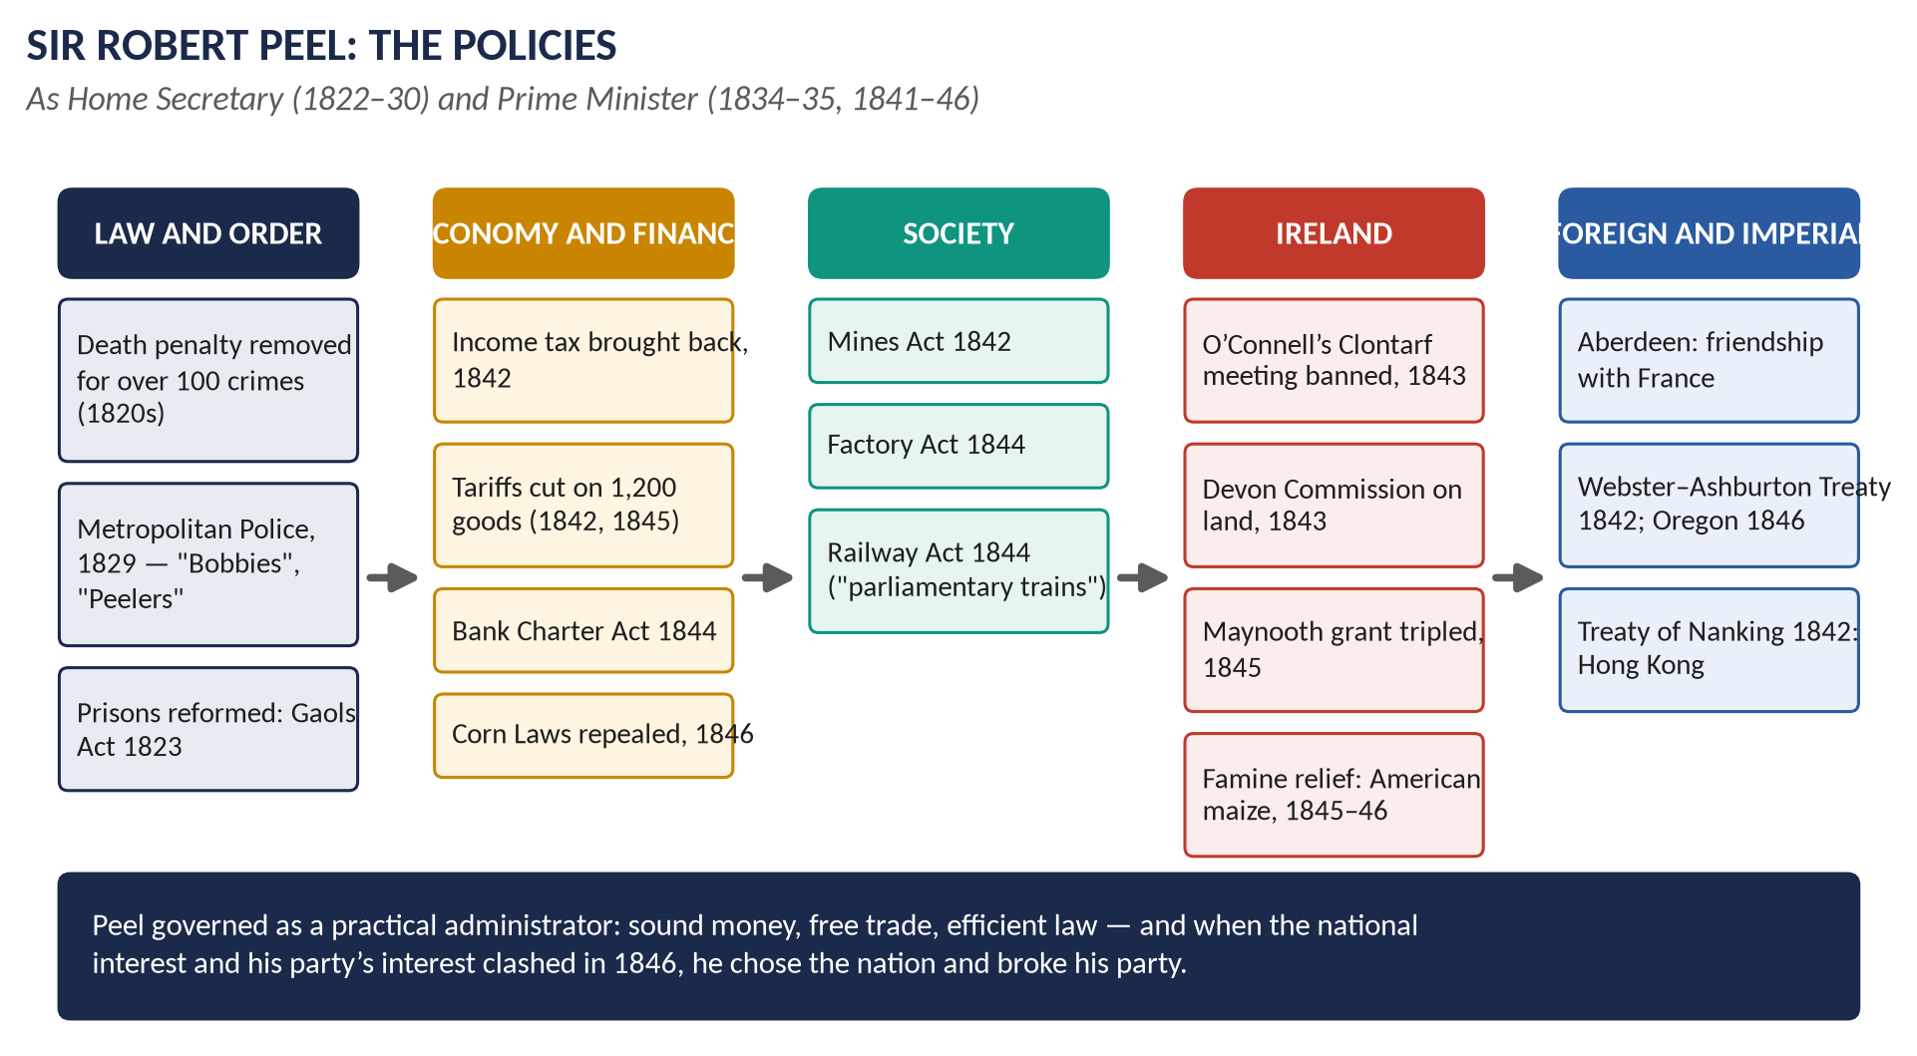
Figure 3 · Sir Robert Peel's policies at a glance.

4.1 His life and career
Year | Event
1788 | Born in Lancashire, son of a rich cotton manufacturer — not an aristocrat.
1809 | MP at 21, after Harrow and Oxford (a double first).
1812–18 | Chief Secretary for Ireland: set up the Peace Preservation Force (1814); opposed Catholic claims — nicknamed "Orange Peel".
1819 | Chaired the committee that returned Britain to the gold standard.
1822–27, 1828–30 | Home Secretary: criminal law, prisons, the Metropolitan Police (1829).
1829 | Carried Catholic Emancipation through the Commons — lost his Oxford University seat.
1834 | Tamworth Manifesto; PM for about 100 days (Dec 1834 – April 1835).
1839 | Bedchamber Crisis: refused office when the young Queen would not change her Whig ladies-in-waiting.
1841–46 | Prime Minister with a majority of about 80.
1846 | Repealed the Corn Laws; defeated the same night on an Irish bill; resigned.
1850 | Died after a fall from his horse.

4.2 The Tamworth Manifesto (December 1834)
Addressed to the voters of his constituency, Tamworth, but really to the whole country, it is often called the first party manifesto. Peel said:
- The Reform Act was "a final and irrevocable settlement" of the question — the Conservatives would not try to reverse it.
- The Conservatives would review institutions "in a friendly temper", correcting proven abuses and redressing real grievances — but would not follow "a perpetual vortex of agitation".
KEY IDEA · Why Tamworth matters
It turned the old Tory party of resistance into the modern Conservative Party — a party that conserves by reforming. It appealed to the new middle-class voters and brought Peel a majority in 1841.

4.3 Interior (domestic) policy as Prime Minister, 1841–46

(i) Finance and the economy
- The problem: a deficit of about £7.5 million and a depression (1837–42).
- Budget of 1842: income tax brought back in peacetime — 7d in the pound on incomes over £150 (so the poor did not pay); import duties cut on about 750 items.
- Budget of 1845: duties abolished on about 450 items, including all export duties and the duty on raw cotton.
- Result: trade revived; by 1845 the budget was in surplus.
- Bank Charter Act (1844): only the Bank of England could issue new banknotes, and its notes had to be backed by gold — stable money.
- Companies Act (1844) and Railway Act (1844): the "parliamentary train" — at least one train a day on every line at 1d a mile (Gladstone at the Board of Trade).

(ii) Social reforms
- Mines Act (1842): no women or girls, and no boys under 10, underground (Lord Ashley's campaign).
- Factory Act (1844): women limited to 12 hours; children 6½ hours; dangerous machinery fenced.
- Peel refused the Ten Hours Bill — he feared it would harm industry.

(iii) The repeal of the Corn Laws (1846)
- The Corn Laws (1815, sliding scale 1828, 1842) protected landowners by taxing imported grain.
- Pressure: the Anti-Corn Law League (1838) of Richard Cobden and John Bright — a brilliantly organised middle-class campaign.
- Peel's conversion: by the early 1840s he believed in free trade — cheap food meant lower wages costs, more trade and a contented people.
- The trigger: the Irish potato blight (autumn 1845). Peel said it was impossible to keep the ports closed while Irish people starved.
- The vote: the repeal passed in May–June 1846 with Whig votes; about 231 Conservatives voted against and only about 112 with Peel.
- The fall: on the same night (25 June 1846) the Protectionists, led by Lord George Bentinck and Disraeli, joined the Whigs and Irish to defeat Peel's Irish Coercion Bill. He resigned.
- Consequences: the Conservative Party split — the Protectionists (Derby, Disraeli) and the Peelites (Gladstone, Aberdeen). The Conservatives did not win a majority again until 1874. Free trade became national policy for the rest of the century.

4.4 The Irish issue
Ireland was Peel's greatest problem, and he knew it well from his years as Chief Secretary.

(i) Firmness — the Repeal campaign
- Daniel O'Connell launched a campaign to repeal the Act of Union (1840), with "monster meetings" of hundreds of thousands (1843 — "the Repeal Year").
- Peel banned the great meeting at Clontarf (October 1843); O'Connell obeyed, was arrested, convicted of conspiracy (sentence later quashed by the Lords). The Repeal movement collapsed.

(ii) Conciliation — "killing Repeal by kindness"
- The Devon Commission (1843–45) investigated the land system — landlord and tenant.
- The Maynooth Grant (1845): the annual grant to the Catholic seminary at Maynooth was raised from about £9,000 to about £26,000 and made permanent. Many Protestant Tories were furious; Gladstone resigned from the cabinet over it.
- Queen's Colleges (1845): non-denominational colleges at Belfast, Cork and Galway — attacked by Catholics as "godless colleges".
- Charitable Bequests Act (1844): made it easier to give money to the Catholic Church.

(iii) The Great Famine
- 1845: a fungus, potato blight, destroyed about a third to a half of the potato crop — the main food of about 3 million Irish people.
- Peel's response: he secretly bought £100,000 of Indian corn (maize) from America to keep prices down; set up a Relief Commission and public works; and — above all — repealed the Corn Laws.
- After Peel: the Whig government of Lord John Russell (1846–52) relied more on the free market and the Poor Law; the blight returned in 1846–48. About one million died and about one million emigrated (1845–51).
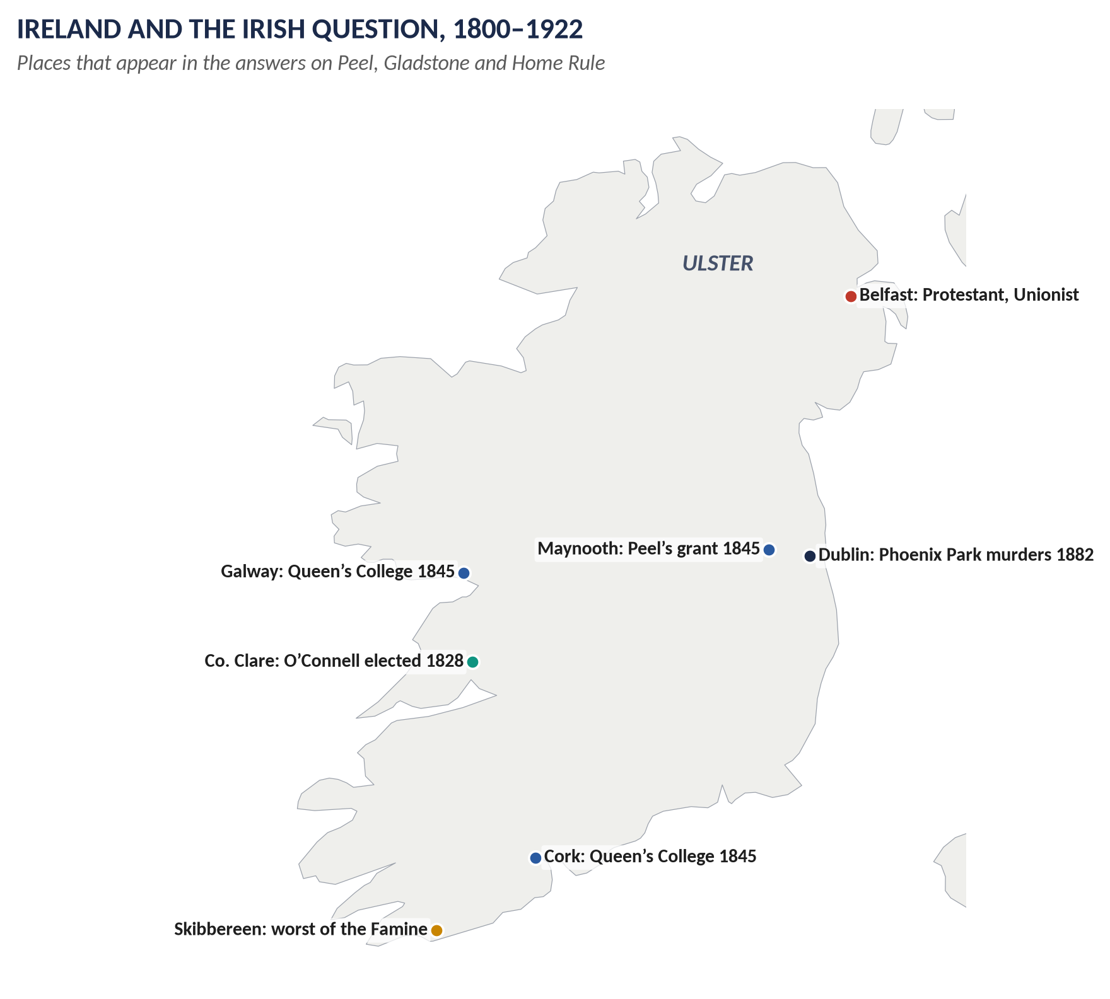
Figure 4 · Ireland and the Irish Question, 1800–1922.

4.5 Exterior (foreign and imperial) policy, 1841–46
Peel left foreign affairs mainly to his friend Lord Aberdeen, whose policy was peace and conciliation — a contrast with the aggressive Palmerston before and after him.
- France: the first "entente cordiale" — Queen Victoria visited King Louis Philippe at Eu (1843); a quarrel over Tahiti (the Pritchard affair, 1844) was settled peacefully.
- The United States: the Webster–Ashburton Treaty (1842) settled the border between Maine and New Brunswick (Canada); the Oregon Treaty (1846) fixed the border on the 49th parallel to the Pacific.
- China: the First Opium War (begun 1839) ended with the Treaty of Nanking (1842): Hong Kong ceded to Britain; five ports opened.
- India and Afghanistan: withdrawal from the disastrous First Afghan War (1842); conquest of Sind (1843); the First Anglo-Sikh War (1845–46).

4.6 Peel's methods of governance — compared with his predecessors
 | Liverpool (1812–27) | Canning (1827) · Wellington (1828–30) | Peel (1841–46)
Style | Conciliator and manager; chairman of a team | Canning: brilliant orator, divisive · Wellington: soldier, gave orders | Hands-on executive: supervised every department himself
Cabinet | Let strong ministers run departments | Canning: faction-ridden · Wellington: treated ministers like officers | Dominated it; drafted budgets himself
Party | Kept "Ultras" and liberals together | Canning split the Tories; Wellington lost the Ultras (1829) and the reformers (1830) | Built a party (Tamworth, Carlton Club), then ignored its backbenchers — split 1846
Public opinion | Little appeal to it | Canning appealed to it; Wellington ignored it | Appealed to the nation (Tamworth); governed for the "national interest"
Policy-making | Pragmatic; repression then reform | Canning: foreign policy; Wellington: resist, then give way | Evidence-based: Royal Commissions, statistics, expert advice

KEY IDEA · How far did Peel differ?
Continuity: all four were pragmatic Tories; Peel was trained under Liverpool and continued the liberal Toryism of the 1820s. Differences: Peel governed far more personally, professionally and on evidence; he appealed to the country over the heads of his party; and, unlike Liverpool, he would not compromise with his backbenchers — which made him the greatest administrator of the century and the destroyer of his own party.

4.7 "The most liberal of conservatives and the most conservative of liberals"

(i) The liberal Peel
Criminal-law and prison reform; the police; Catholic Emancipation (1829); acceptance of the Reform Act (Tamworth); free trade budgets; Corn Law repeal; Maynooth; the Mines and Factory Acts.

(ii) The conservative Peel
He opposed the Reform Act of 1832; defended the Church of England and the Union with Ireland; believed in order (police, coercion in Ireland) and sound money (gold standard, Bank Charter Act); refused the Ten Hours Bill; never wanted democracy.

(iii) Reconciling the two
Peel's aim was always conservative — to preserve the Crown, the Church, property and the aristocratic constitution. His means were often liberal — to remove grievances before they caused revolution. As Tamworth said: correct proven abuses to preserve institutions.

(iv) What others said
- Disraeli: Peel "caught the Whigs bathing and walked away with their clothes"; "a Conservative government is an organised hypocrisy" (1845).
- Gladstone called him the greatest man he had ever known; the Peelites became the core of the Liberal Party.
- Norman Gash (biographer): Peel was the founder of modern Conservatism.
WHAT THE EXAMINER HAS ASKED · Where Chapter 4 has been asked
2018 Q4 (interior and exterior policy, with emphasis on Ireland) · 2020 Q5 ("most liberal of conservatives…") · 2024 Q1 (his methods compared with Liverpool, Canning and Wellington). MCQ 2025: the PM who repealed the Corn Laws → Robert Peel; 2026: the Irish Famine was caused by the failure of the potato.

Chapter 5 · The Road to Democracy, 1832–1928 — and On to 2026
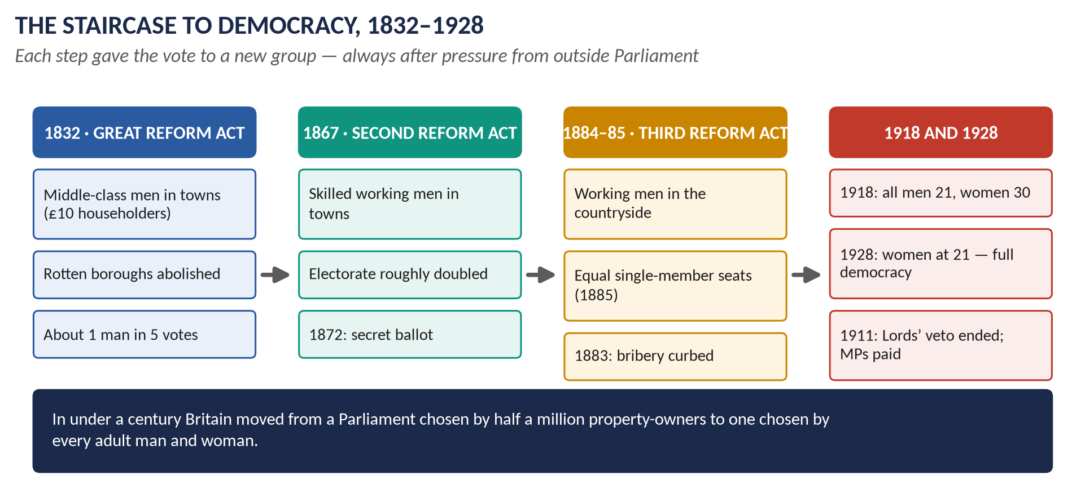
Figure 5 · The staircase to democracy, 1832–1928.

5.1 Step by step
Year | Law | What it did, simply
1832 | Great Reform Act (Grey, Whig) | Middle-class men (£10 householders) in towns; 143 seats redistributed; about 1 man in 5 votes.
1858 | Property Qualification Act | MPs no longer had to own land — a Chartist demand.
1867 | Second Reform Act (Derby and Disraeli, Conservative) | Vote for all male householders in boroughs and £10 lodgers; £12 occupiers in counties. Electorate about 1.4 → 2.5 million. Urban working men could now vote.
1872 | Ballot Act (Gladstone, Liberal) | Secret voting on paper — no more intimidation by landlords and employers.
1883 | Corrupt and Illegal Practices Act (Gladstone) | Strict limits on election spending; bribery punished.
1884 | Third Reform Act (Gladstone) | Household vote extended to the counties: farm labourers and miners. Electorate about 3.1 → 5.7 million — about two men in three.
1885 | Redistribution of Seats Act | Most constituencies became single-member, of roughly equal size (about 50,000 people).
1911 | Parliament Act (Asquith, Liberal) | The Lords could delay bills for two years but not block them; money bills could not be delayed at all; elections at least every five years. MPs paid £400 a year.
1918 | Representation of the People Act (Lloyd George coalition) | Vote for all men over 21 and women over 30 (with a small property qualification). Electorate about 7.7 → 21.4 million. Women could become MPs.
1928 | Equal Franchise Act (Baldwin, Conservative) | Women vote at 21 on the same terms as men. Electorate about 28.9 million. Full democracy.

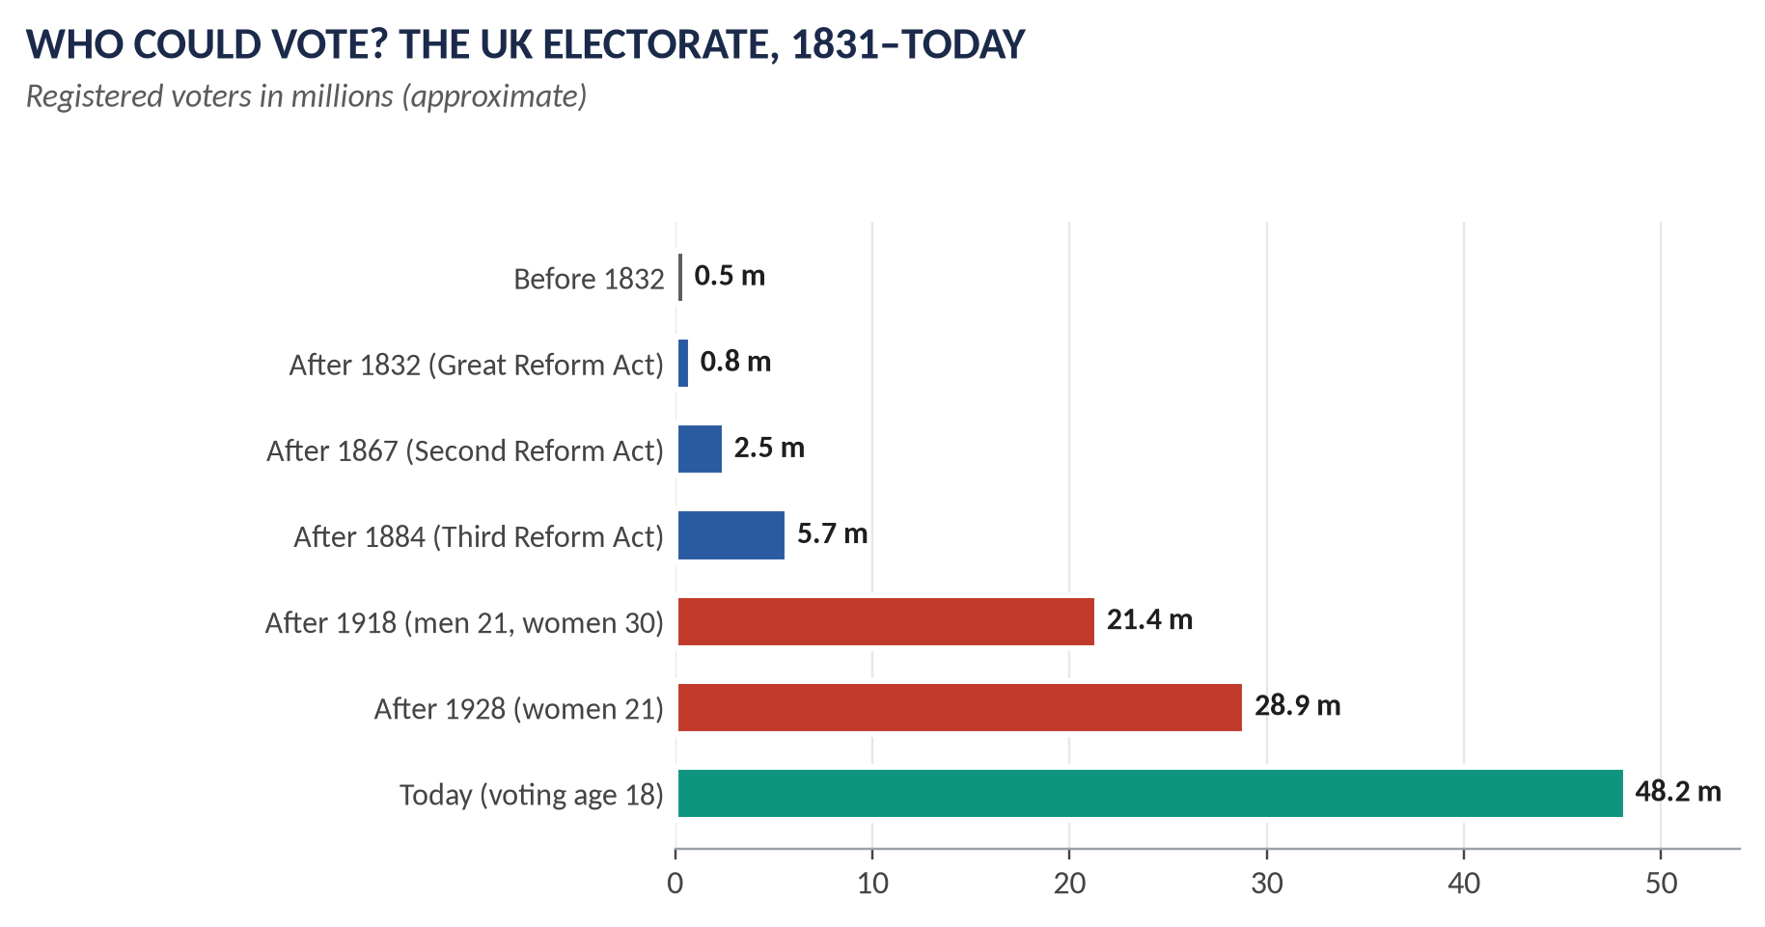
Figure 6 · The growth of the electorate.

5.2 Why did Britain become a democracy? — the forces behind each step

(i) Pressure from outside Parliament
- 1832: the Political Unions, riots in Bristol and Nottingham, the Days of May.
- 1838–48: Chartism — no immediate success, but its six points became the agenda (Topic 4).
- 1866–67: the Reform League — a huge demonstration in Hyde Park (July 1866) where the railings were torn down.
- 1903–14: the suffragists (Millicent Fawcett, NUWSS, 1897) and the suffragettes (Emmeline Pankhurst, WSPU, 1903, "Deeds not words").

(ii) Rivalry between the parties
Each party hoped to win the new voters. Disraeli "dished the Whigs" in 1867 by passing a bigger reform than the Liberals had proposed; Gladstone replied with 1884.

(iii) Economic and social change
Industry, towns, education (1870), newspapers and railways created a literate, organised working class that could not be kept out for ever.

(iv) Liberal ideas
J. S. Mill (Considerations on Representative Government, 1861; he proposed votes for women in 1867); belief in education, citizenship and equal rights.

(v) War
The First World War (1914–18): men who had fought, and women who had worked in munitions factories, could not be refused the vote.

5.3 Critical examination — how democratic, and how quickly?
- Gradual and peaceful: Britain reached democracy by evolution, not revolution — each step a law of Parliament.
- From above: every Act was passed by a Parliament of the already-enfranchised; the ruling classes gave ground carefully, to preserve their influence.
- Slow: 96 years from 1832 to 1928; women waited longest.
- Unequal even in 1928: plural voting (a second vote for university graduates and business owners) lasted until 1948; the House of Lords remained unelected.

5.4 After 1928 — the story to 2026
Year | Change
1948 | Plural voting abolished: "one person, one vote". University seats ended.
1949 | Second Parliament Act: the Lords' delay cut to one year.
1958 | Life Peerages Act: life peers, including the first women peers.
1969 | Voting age lowered to 18.
1999 | House of Lords Act: most hereditary peers removed (92 kept). Devolved parliaments for Scotland and Wales and an assembly for Northern Ireland (1998–99).
2000 | Electoral Commission set up to oversee elections and party funding.
2011 / 2022 | Fixed-term Parliaments Act (2011) set five-year terms; repealed by the Dissolution and Calling of Parliament Act (2022), restoring the PM's power to call elections.
2022 | Elections Act: photo ID required to vote in Great Britain (from 2023).
2024–25 | The Labour government (elected July 2024) introduced a bill to remove the remaining hereditary peers and, in 2025, announced plans to lower the voting age to 16 for all UK elections.

WHAT THE EXAMINER HAS ASKED · Where Chapter 5 has been asked
2018 Q5 ("measures for the democratisation of Parliament over the decades") · 2020 Q4 ("history of parliamentary reforms 1832–1928 … how England became democratic"). MCQ 2026: women over 30 first got the vote in 1918 (none of the options).

Chapter 6 · The Evolution of Party Politics in the 19th Century
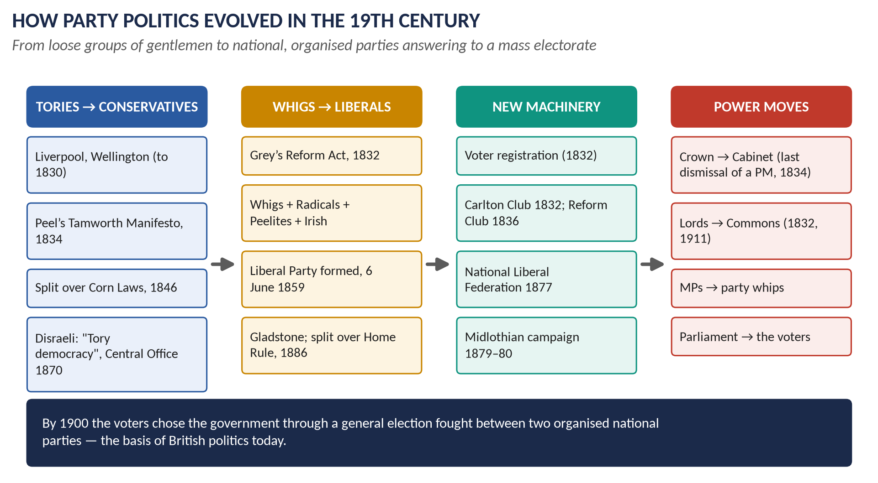
Figure 7 · How party politics evolved.

6.1 What a party was in 1815
In 1815 "Whig" and "Tory" (names from the 1680s — Topic 1) meant loose groupings of gentlemen in Parliament, linked by family, friendship and patronage. There were no party members in the country, no national organisation, no programmes. Many MPs were independent country gentlemen. The Crown still chose the ministers, and governments usually won elections.

6.2 Stage 1 · 1832–1846: the birth of modern parties
- Registration (1832): voters had to register — so each party needed local agents and registration societies to get its supporters on the list.
- Clubs: the Carlton Club (1832) for Conservatives, the Reform Club (1836) for Whigs and Liberals — central offices in all but name.
- The name "Conservative": first used about 1830 (J. W. Croker in the Quarterly Review); fixed by Peel's Tamworth Manifesto (1834).
- The Whig alliance: the Lichfield House Compact (1835) joined Whigs, Radicals and O'Connell's Irish members.
- The Crown's power declines: William IV's dismissal of Melbourne (1834) failed; after Victoria's Bedchamber Crisis (1839) no monarch tried again.

6.3 Stage 2 · 1846–1867: fluid parties
- The Corn Law split (1846) broke the Conservatives into Protectionists (Derby, Disraeli) and Peelites (Gladstone, Aberdeen, Graham).
- Governments were coalitions and fell often; MPs voted freely — the "golden age of the private member" and of the independent Commons.
- 6 June 1859: at Willis's Rooms, London, Whigs, Radicals, Peelites and Irish members agreed to unite — the birth of the Liberal Party, led by Palmerston.

6.4 Stage 3 · 1867–1886: mass parties
After the Second Reform Act (1867) the electorate was too large to bribe or manage personally; parties had to organise and persuade.

(i) The Conservatives
- National Union of Conservative and Constitutional Associations (1867) — local clubs, including working-men's clubs.
- Conservative Central Office (1870), run by John Gorst.
- Disraeli's great speeches at Manchester and the Crystal Palace (1872): the party would stand for the constitution, the empire and social reform — "Tory democracy", "One Nation".
- The Primrose League (1883) — a mass organisation with over a million members by 1891.

(ii) The Liberals
- The Birmingham "caucus": Joseph Chamberlain's efficient ward-by-ward organisation.
- National Liberal Federation (1877).
- Gladstone's Midlothian campaign (1879–80): the first modern election campaign — a party leader touring the country and speaking directly to mass audiences.

6.5 Stage 4 · 1886–1900: realignment
- Home Rule split (1886): Liberal Unionists (Hartington, Chamberlain) joined the Conservatives; the Unionists dominated until 1905.
- The Newcastle Programme (1891): a Liberal list of promises — the ancestor of the modern manifesto.
- The rise of Labour: the Independent Labour Party (1893) and the Labour Representation Committee (1900), which became the Labour Party (1906).

6.6 Disraeli and "Tory democracy"
- Second Reform Act (1867): Disraeli "dished the Whigs" and caught the new working-class voter.
- Social reforms of 1874–80 (with Richard Cross at the Home Office): Artisans' Dwellings Act (1875 — slum clearance), Public Health Act (1875), Sale of Food and Drugs Act (1875), Conspiracy and Protection of Property Act (1875 — peaceful picketing legal), Employers and Workmen Act (1875), Merchant Shipping Act (1876 — the Plimsoll line), Factory Act (1878), Education Act (1876).
- Empire: Suez Canal shares (1875); Queen Victoria Empress of India (1876) — Topic 6.

6.7 The changing relationship between government, Parliament and the electorate
Relationship | Early in the century | By 1900
Crown and government | The monarch chose and could dismiss ministers | The monarch accepts whoever wins the election; Bagehot (1867): the Crown is a "dignified" part, the Cabinet the "efficient" part
Lords and Commons | Lords equal or stronger; many MPs nominated by peers | Commons clearly dominant (after 1832; confirmed 1911)
Government and Commons | Loose party loyalties; MPs vote freely; governments fall in the Commons | Party whips and discipline; the government controls Commons time; the closure (1882, after Irish obstruction)
Parliament and electorate | A small electorate; many seats uncontested; governments made in Parliament | A mass electorate; national campaigns; the voters choose the government — in 1868 Disraeli resigned after losing the election, without waiting to meet Parliament, the first PM to do so

WHAT THE EXAMINER HAS ASKED · Where Chapter 6 has been asked
2025 Q4: the evolution of party politics, the rise of the Conservatives and Liberals, and the relationship between government, Parliament and the electorate. MCQ 2025: the economic policy that dominated Victorian Britain → free trade.

Chapter 7 · Gladstone's Domestic Policy — the Climax of Liberalism?
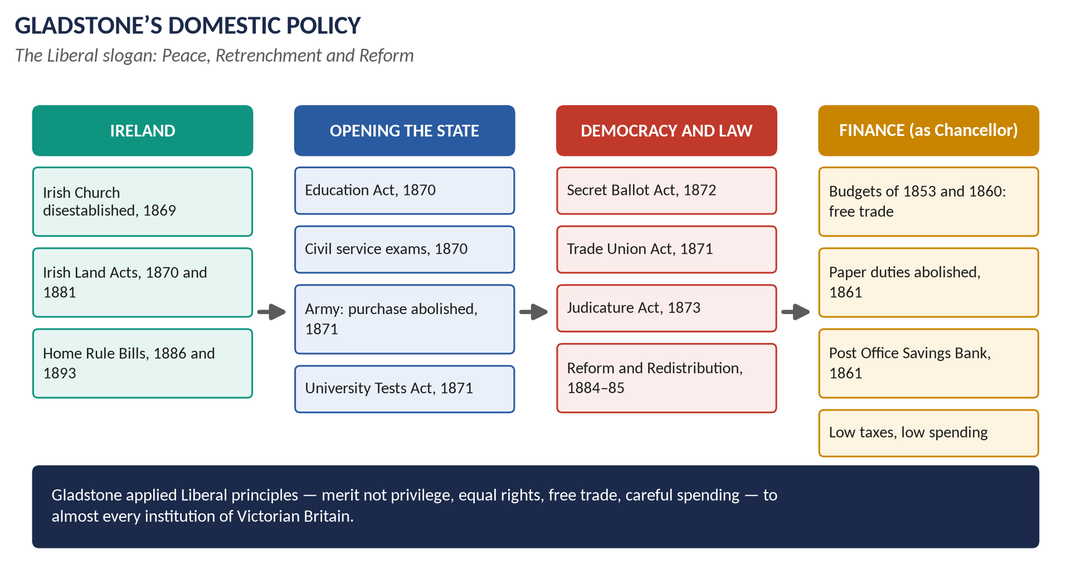
Figure 8 · Gladstone's domestic policy at a glance.

7.1 Who was Gladstone?
William Ewart Gladstone (1809–98), son of a rich Liverpool merchant, began as a young Tory ("the rising hope of those stern and unbending Tories", said Macaulay), became a Peelite after 1846, a Liberal from 1859, and led the Liberal Party for most of the next 35 years. He was Chancellor of the Exchequer (1852–55, 1859–66) and Prime Minister four times: 1868–74, 1880–85, 1886 and 1892–94 — the last time at the age of 84. He was deeply religious and believed politics was a moral duty. People called him the "Grand Old Man" (GOM).

7.2 What was nineteenth-century liberalism?
- Individual freedom: of religion, speech, trade and contract.
- Merit, not privilege: careers open to talent; an end to jobs and commissions bought or inherited.
- Equal rights before the law and in politics.
- Free trade and laissez-faire.
- "Peace, Retrenchment and Reform": peace abroad; retrenchment = cutting government spending and taxes; reform of abuses.

7.3 Gladstone as Chancellor — the financial foundations
- Budget of 1853: cut duties on over 100 goods; planned to end income tax (the Crimean War prevented it).
- Budget of 1860, with the Cobden–Chevalier Treaty with France: duties removed on almost all imports — Britain became a free-trade nation.
- Paper duties abolished (1861) — the Lords blocked it in 1860; Gladstone put all taxes into one Finance Bill, so the Lords could not pick one out — cheaper newspapers.
- Post Office Savings Bank (1861): safe saving for working people.
- Retrenchment: "Every shilling spent must be justified"; money should "fructify in the pockets of the people".

7.4 The first ministry (1868–74) — "the great ministry"
Reform | Year | What it did, and the liberal principle behind it
Irish Church Act | 1869 | Disestablished the Protestant Church of Ireland (it was no longer the official church of a Catholic country). Principle: religious equality.
Irish Land Act | 1870 | Compensation for evicted tenants and for improvements they had made. Principle: justice for Ireland — though too weak.
Forster's Education Act | 1870 | Elected school boards to build "board schools" wherever church schools were not enough; the Cowper-Temple clause: no denominational teaching in board schools. Principle: an educated citizenry ("we must educate our masters").
Civil Service reform | 1870 | Entry by open competitive examination (following the Northcote–Trevelyan Report, 1854), except in the Foreign Office. Principle: merit, not patronage.
Cardwell's army reforms | 1868–74 | Purchase of commissions abolished (1871, by royal warrant when the Lords blocked the bill); short service (6 years + 6 in reserve); flogging abolished in peacetime; regiments linked to counties; the War Office reorganised. Principle: merit and efficiency.
University Tests Act | 1871 | Oxford, Cambridge and Durham opened to non-Anglicans. Principle: religious equality.
Trade Union Act | 1871 | Unions became legal bodies able to protect their funds. But the Criminal Law Amendment Act (1871) made picketing illegal — angering workers.
Local Government Board | 1871 | One department for poor law and public health.
Ballot Act | 1872 | Secret voting. Principle: political freedom.
Licensing Act | 1872 | Limited pub opening hours — angered brewers and drinkers.
Judicature Act | 1873 | Merged the old courts into one Supreme Court of Judicature (High Court and Court of Appeal). Principle: efficiency.

Gladstone lost the 1874 election: "We have been borne down in a torrent of gin and beer," he wrote. Nonconformists were angry at the Education Act, workers at the Criminal Law Amendment Act, publicans at the Licensing Act.

7.5 The second ministry (1880–85)
- Irish Land Act (1881): the "three Fs" — fair rent (set by a Land Court), fixity of tenure (no eviction while rent was paid), free sale (of the tenant's interest).
- Arrears Act (1882).
- Married Women's Property Act (1882): married women could own property in their own right.
- Corrupt and Illegal Practices Act (1883).
- Third Reform Act (1884) and Redistribution Act (1885).
- Mundella's Education Act (1880): school compulsory from 5 to 10. Employers' Liability Act (1880).

7.6 The third and fourth ministries (1886, 1892–94)
- First Home Rule Bill (1886) and second (1893) — Chapter 8.
- Local Government Act (1894): elected parish and district councils, open to women.
- Death duties (Harcourt's budget, 1894) — the beginning of redistributive taxation.

7.7 Was it "the climax of liberalism"?

(i) Yes
- He applied the liberal principles of merit, equality, freedom and free trade to almost every institution: the army, the civil service, the universities, the schools, the courts, the Church, elections.
- The first ministry is often called the greatest reforming ministry of the century.
- He gave liberalism a moral and popular force: Midlothian, the "people's William".
- Free trade and balanced budgets reached their peak.

(ii) But
- Laissez-faire limits: he did little about poverty, housing or health — Disraeli's government did more on social reform.
- His reforms angered his own supporters (1874).
- Home Rule split the party (1886), and the Liberals were out of power for most of 1886–1905.
- After him, liberalism changed: the New Liberalism of 1906–14 (old-age pensions, national insurance, the "People's Budget") used the state to help the poor — something Gladstone distrusted. So his era was the climax of classical liberalism, and also its end.
WHAT THE EXAMINER HAS ASKED · Where Chapter 7 has been asked
2017 Q5 and 2022 Q2 — the same question in almost the same words: "Gladstone's domestic policy was the climax of liberalism."

Chapter 8 · The Irish Question

8.1 Defining the Irish Question
The Irish Question was the problem of how Ireland should be governed, and how the grievances of its mainly Catholic, mainly rural people could be met, within the United Kingdom. It had three strands:
1. Land: most land was owned by Protestant landlords (many living in England — "absentees"); most Irish people were Catholic tenant farmers with no security, who could be evicted at will and whose improvements raised their own rents.
2. Religion: the Protestant Church of Ireland was the official church, paid for by tithes from a mainly Catholic people; Catholics were excluded from Parliament until 1829.
3. Government: after the Act of Union (1801) Ireland was ruled from London; many Irish wanted their own parliament — first "Repeal" (O'Connell), then "Home Rule" (Butt, Parnell), later independence.
In the north-east (Ulster) a Protestant majority wanted to stay in the Union — a fourth complication.

8.2 From the Union to 1885
Year | Event
1801 | Act of Union: Ireland's parliament abolished; Ireland joins the UK (Topic 3).
1829 | Catholic Emancipation after O'Connell's Clare election.
1840–43 | O'Connell's Repeal campaign; Clontarf banned (1843).
1845–49 | The Great Famine: about 1 million dead, 1 million emigrants; population fell from about 8.2 million (1841) to 6.5 million (1851).
1858–67 | The Fenians (Irish Republican Brotherhood): a failed rising (1867); the Manchester "martyrs"; the Clerkenwell explosion.
1868 | Gladstone: "My mission is to pacify Ireland."
1869–70 | Church disestablished; first Land Act.
1870–73 | Isaac Butt founds the Home Government Association (1870) and the Home Rule League (1873).
1879–82 | Michael Davitt's Land League; the "Land War"; the boycott (named after Captain Boycott, 1880); Land Act 1881 (three Fs); Kilmainham Treaty (1882); the Phoenix Park murders (May 1882) of the new Chief Secretary, Lord Frederick Cavendish.
1885 | General election: Parnell's Home Rulers win 86 seats — exactly the gap between Liberals (335) and Conservatives (249). In December the "Hawarden Kite" reveals that Gladstone now supports Home Rule.

8.3 The Liberal policy, 1886–1894

(i) The First Home Rule Bill (April 1886)
- What it proposed: an Irish parliament in Dublin to run Ireland's domestic affairs; the UK Parliament kept control of the Crown, defence, foreign policy, trade and customs; Irish MPs would leave Westminster. A Land Purchase Bill would buy out landlords.
- Why Gladstone did it: justice for Ireland — the Irish had voted clearly for Home Rule; coercion had failed; Home Rule would save the Union by removing a grievance; and Parnell's votes held the balance.
- Opposition: Conservatives; the Whig Liberals under Lord Hartington (fear for property and the empire); the Radical Joseph Chamberlain (who wanted local councils, not a separate parliament); Ulster Protestants ("Home Rule means Rome Rule"; Lord Randolph Churchill: "Ulster will fight, and Ulster will be right").
- The vote (8 June 1886): defeated 343 to 313 — 93 Liberals voted against.

(ii) The Liberal split and the Unionist years (1886–92)
- The dissidents formed the Liberal Unionists and allied with the Conservatives. At the election of July 1886 the Unionists won; Lord Salisbury governed until 1892 (policy: coercion under Arthur Balfour, "Bloody Balfour", plus land purchase — "killing Home Rule with kindness").
- 1887–89: The Times printed letters linking Parnell with the Phoenix Park murders — they were forged by Richard Pigott (exposed 1889); Liberal sympathy for Parnell rose.
- 1890: Parnell was named in the O'Shea divorce case; Nonconformist Liberals would not work with him; Gladstone demanded his retirement; the Irish party split. Parnell died in 1891.
- 1891: the Newcastle Programme put Home Rule first among Liberal promises.

(iii) The Second Home Rule Bill (1893)
- 1892 election: Liberals and Irish Nationalists together had a majority of about 40.
- The bill (February 1893) kept 80 Irish MPs at Westminster.
- It passed the Commons (third reading, 1 September 1893) by 301 to 267 after 82 sittings — but the House of Lords threw it out 419 to 41 (8 September 1893).
- Gladstone wanted to fight an election against the Lords; his cabinet refused. He resigned in March 1894 (also over naval spending). His successor Lord Rosebery quietly dropped Home Rule, saying England, "the predominant partner", must first be convinced.

8.4 Assessment of the Liberal policy
For | Against
Principled and far-sighted: Gladstone accepted the Irish people's democratic verdict | Split the Liberal Party: it lost its Whig and Radical-Unionist wings and most of its wealth
A peaceful, constitutional answer that might have prevented later violence | Ignored Ulster: no special treatment for the Protestant north
Made Home Rule the policy of one of the two great parties | Failed twice; the Lords could block it until 1911
Kept Irish nationalism constitutional for another generation | Tied the Liberals to Irish votes; the Unionists ruled for most of 1886–1905

8.5 What happened next — to 2026
- 1912–14: the Third Home Rule Bill (Asquith), passed under the Parliament Act (1914) but suspended for the war; the Ulster crisis (Ulster Volunteers, Curragh incident).
- 1916: the Easter Rising in Dublin; the executions turned Irish opinion to Sinn Féin.
- 1919–21: the War of Independence; the Government of Ireland Act (1920) created Northern Ireland (1921).
- 1921–22: the Anglo-Irish Treaty; the Irish Free State (1922); civil war.
- 1949: the Republic of Ireland leaves the Commonwealth.
- 1968–98: "the Troubles" in Northern Ireland; about 3,500 killed; the Good Friday Agreement (1998) brought power-sharing.
- 2020–26: Brexit and the Northern Ireland Protocol, revised by the Windsor Framework (2023); in 2024 power-sharing returned and Michelle O'Neill of Sinn Féin became the first nationalist First Minister of Northern Ireland.
WHAT THE EXAMINER HAS ASKED · Where Chapter 8 has been asked
2024 Q2: define the Irish Question; the Liberal policy 1886–94. Ireland also forms the "particular emphasis" of 2018 Q4 on Peel.

Part Four — Historians and Quotations
Historian or writer | The view to quote
Norman Gash, Politics in the Age of Peel (1953); Sir Robert Peel (1972) | 1832 changed less than it seemed; Peel the founder of modern Conservatism.
Asa Briggs, The Age of Improvement (1959) | The years 1783–1867 as an age of steady, practical improvement.
Walter Bagehot, The English Constitution (1867) | The "dignified" parts (the Crown, the Lords) and the "efficient" part (the Cabinet).
Robert Blake, Disraeli (1966) | Disraeli as the opportunist who built the modern Conservative Party.
H. C. G. Matthew, Gladstone (1986–95) | Gladstone's finance and his moral vision as the heart of Victorian Liberalism.
John Morley, Life of Gladstone (1903) | The admiring official life.
G. M. Young, Victorian England (1936) | The Victorian "age of reform" as a triumph of peaceful change.
F. S. L. Lyons | Parnell and the Home Rule movement.

"A final and irrevocable settlement of a great constitutional question." — Peel on the Reform Act, Tamworth Manifesto, 1834
"Reform, that you may preserve." — Macaulay, speech on the Reform Bill, 1831
"My mission is to pacify Ireland." — Gladstone, 1868
"A Conservative government is an organised hypocrisy." — Disraeli on Peel, 1845
"We must educate our masters." — attributed to Robert Lowe, after 1867

Part Five — The Examiner's Record
Paper | The question as set | Family | Type
2015 · Q6 · Paper I | The short reign of William IV is considered to be the long era of bills and acts. Substantiate the statement with supportive arguments. | Parliamentary reform 1832–1928 | Quotation / claim
2016 · Q3 · Section A | Analyze critically the Reform Act of 1832. | Parliamentary reform 1832–1928 | Impact / significance
2017 · Q5 · Section A | 'Gladstone's domestic policy was the climax of liberalism.' Discuss comprehensively. | Gladstone's domestic policy | Quotation / claim
2018 · Q4 · Section A | Shed ample light on the interior as well as exterior policy of Sir Robert Peel as British Premier, with particular emphasis on the Irish issue. | Sir Robert Peel | Policy analysis
2018 · Q5 · Section A | What measures were taken for the democratisation of the British Parliament over the decades? | Parliamentary reform 1832–1928 | Describe / account
2019 · Q5 · Section A | The Reform Act of 1832 made possible the series of political and administrative reforms that laid the foundation of modern Britain. Discuss. | Parliamentary reform 1832–1928 | Quotation / claim
2020 · Q4 · Section A | Give a history of parliamentary reforms between 1832 and 1928. Also critically examine how England became a politically democratic country. | Parliamentary reform 1832–1928 | Describe / account
2020 · Q5 · Section A | 'Peel was the most liberal of conservatives and the most conservative of liberals.' Examine the statement critically. | Sir Robert Peel | Quotation / claim
2022 · Q2 · Section A | The domestic policy of Gladstone was the climax of liberalism during the 19th century. Discuss and analyze. | Gladstone's domestic policy | Quotation / claim
2024 · Q1 · Section A | How far did Robert Peel's methods of governance differ from those of his predecessors, viz. Liverpool, Canning and Wellington? | Sir Robert Peel | Compare / contrast
2024 · Q2 · Section A | Define the 'Irish Question'. Also discuss the policy of the Liberal Party on the said issue from 1886 to 1894. | The Irish Question and Home Rule | Policy analysis
2025 · Q4 · Section A | Examine the evolution of party politics in Britain during the 19th century, focusing on the rise of the Conservative and Liberal parties, and the changing relationship between government, parliament and the electorate. | Rise of the Conservative and Liberal parties | Describe / account

WHAT THE EXAMINER HAS ASKED · The pattern
Parliamentary reform is the favourite: the 1832 Act alone (2016, 2019), the "era of bills and acts" under William IV (2015), and the whole road to democracy (2018, 2020). Peel comes back every two or three years — his policies (2018), his character (2020), his methods (2024). Gladstone's domestic policy has been set twice in the same words (2017, 2022). The Irish Question (2024) and party politics (2025) are the newest angles. Never yet asked as full questions: Liverpool's government, Catholic Emancipation, the repeal of the Corn Laws on its own, Disraeli's domestic policy, and the 1911 Parliament Act.

Part Six — The One-Liner Bank
HOW TO USE THIS · How to use the one-liners
Cover the answer after the arrow and say it aloud. 120 questions; bold words are the ones examiners test. The past MCQs are solved in T5QA.

One-liners · Tory Britain, 1815–1830
1. Who was Tory Prime Minister from 1812 to 1827? → Lord Liverpool.
2. Which 1815 law kept out foreign wheat until the price reached 80 shillings? → The Corn Law.
3. Which wartime tax was abolished in 1816? → Income tax.
4. In which city did the Peterloo Massacre happen (1819)? → Manchester (St Peter's Fields).
5. Who was the main speaker at Peterloo? → Henry "Orator" Hunt.
6. About how many were killed at Peterloo? → About 15, with hundreds injured.
7. Which laws of 1819 restricted meetings and newspapers? → The Six Acts.
8. Which 1820 plot aimed to murder the whole cabinet? → The Cato Street Conspiracy.
9. Which Home Secretary reformed the criminal law in the 1820s? → Robert Peel.
10. Which Act of 1829 created the London police? → The Metropolitan Police Act.
11. What were the first policemen nicknamed? → "Bobbies" or "Peelers".
12. Who reduced import duties at the Board of Trade (1823–27)? → William Huskisson.
13. When were the Combination Acts repealed, making unions legal? → 1824.
14. Who was PM for only 119 days in 1827? → George Canning.
15. Who was PM 1828–30? → The Duke of Wellington.
16. Which Acts, repealed in 1828, had barred Nonconformists from office? → The Test and Corporation Acts.
17. Which Irish leader's election for County Clare (1828) forced Catholic Emancipation? → Daniel O'Connell.
18. When was Catholic Emancipation passed? → 1829 (Catholic Relief Act).
19. What was the name of O'Connell's organisation? → The Catholic Association.

One-liners · The Great Reform Act and William IV
20. Which Whig PM passed the Reform Act? → Earl Grey.
21. On what date did the Reform Act become law? → 7 June 1832.
22. By how many votes did the first Reform Bill pass its second reading in 1831? → One (302–301).
23. Which cities had riots after the Lords rejected the bill in 1831? → Bristol, Nottingham and Derby.
24. What was the crisis of May 1832 called? → The Days of May.
25. What did William IV finally agree to do? → Create enough new peers to pass the bill.
26. Which Birmingham banker led the Political Union? → Thomas Attwood.
27. What was a rotten borough? → A borough with almost no voters that still elected MPs.
28. Name a famous rotten borough with no inhabitants. → Old Sarum.
29. How many boroughs lost both MPs in 1832? → 56.
30. How many seats were redistributed? → 143.
31. Who got the borough vote in 1832? → £10 householders (middle-class men).
32. Which clause gave county votes to £50 tenants-at-will? → The Chandos clause.
33. How did the UK electorate change in 1832? → About 500,000 → 813,000.
34. Mainly which group gained representation in 1832? → Middle-class men.
35. Who said "Reform, that you may preserve"? → Macaulay.
36. How long did William IV reign? → Seven years (1830–37).
37. Which Act of 1833 abolished slavery in the empire? → The Slavery Abolition Act.
38. How much compensation was paid to slave-owners? → £20 million.
39. Which 1833 Act banned children under 9 from textile mills? → The Factory Act.
40. What was the first government grant for education (1833)? → £20,000.
41. Which 1834 Act created the workhouse system? → The Poor Law Amendment Act.
42. Which 1835 Act created elected town councils? → The Municipal Corporations Act.
43. What began in 1837 under the 1836 Registration Act? → Civil registration of births, marriages and deaths.
44. Which PM did William IV dismiss in 1834? → Lord Melbourne — the last such dismissal.

One-liners · Sir Robert Peel
45. Where was Peel's family fortune made? → In cotton manufacturing (Lancashire).
46. What nickname did Peel earn in Ireland? → "Orange Peel".
47. Which force did Peel create in Ireland (1814)? → The Peace Preservation Force.
48. What was Peel's 1834 address to his voters called? → The Tamworth Manifesto.
49. What did Tamworth call the Reform Act? → "A final and irrevocable settlement".
50. Which crisis of 1839 stopped Peel taking office? → The Bedchamber Crisis.
51. When was Peel's main ministry? → 1841–46.
52. At what rate did Peel bring back income tax (1842)? → 7d in the pound on incomes over £150.
53. Which 1844 Act gave the Bank of England control of banknotes? → The Bank Charter Act.
54. What was a "parliamentary train"? → A daily train at 1d a mile (Railway Act 1844).
55. Which 1842 Act kept women and young boys out of mines? → The Mines Act.
56. Which 1845 grant to a Catholic seminary angered Protestants? → The Maynooth Grant.
57. Which future PM resigned from Peel's cabinet over Maynooth? → Gladstone.
58. Where were the Queen's Colleges (1845)? → Belfast, Cork and Galway.
59. Which great O'Connell meeting did Peel ban in 1843? → Clontarf.
60. Which commission investigated Irish land (1843–45)? → The Devon Commission.
61. What caused the Irish Famine? → Failure of the potato crop (blight).
62. What did Peel secretly buy from America? → Indian corn (maize), £100,000 worth.
63. Which PM repealed the Corn Laws? → Sir Robert Peel (1846).
64. Which League campaigned against the Corn Laws? → The Anti-Corn Law League (1838).
65. Who led it? → Richard Cobden and John Bright.
66. Who led the Protectionist attack on Peel? → Lord George Bentinck and Benjamin Disraeli.
67. What were Peel's followers called after 1846? → The Peelites.
68. Who was Peel's Foreign Secretary? → Lord Aberdeen.
69. Which 1842 treaty settled the Maine–Canada border? → The Webster–Ashburton Treaty.
70. Which 1846 treaty fixed the border on the 49th parallel? → The Oregon Treaty.
71. Which 1842 treaty gave Britain Hong Kong? → The Treaty of Nanking.
72. Who called Peel's government "an organised hypocrisy"? → Disraeli.
73. How did Peel die in 1850? → After a fall from his horse.

One-liners · Reform to democracy, 1832–1928 and after
74. When was the property qualification for MPs abolished? → 1858.
75. Which PM's government passed the Second Reform Act (1867)? → Lord Derby's — carried by Disraeli.
76. Who got the vote in 1867? → Urban working men (borough householders and £10 lodgers).
77. What did Disraeli do to the Whigs in 1867, in the famous phrase? → He "dished the Whigs".
78. Which 1866 demonstration tore down the Hyde Park railings? → The Reform League's.
79. Which 1872 Act introduced the secret ballot? → The Ballot Act.
80. Which 1883 Act limited election spending? → The Corrupt and Illegal Practices Act.
81. Who got the vote in 1884? → Rural working men (county householders).
82. What did the 1885 Redistribution Act create? → Mostly single-member constituencies of equal size.
83. What did the Parliament Act 1911 do? → Ended the Lords' veto (two-year delay only).
84. When were MPs first paid? → 1911 (£400 a year).
85. When did women over 30 first get the vote? → 1918.
86. Which Act gave women the vote at 21? → The Equal Franchise Act 1928.
87. Who led the suffragettes (WSPU, 1903)? → Emmeline Pankhurst.
88. Who led the suffragists (NUWSS)? → Millicent Fawcett.
89. When was plural voting abolished? → 1948.
90. When was the voting age lowered to 18? → 1969.
91. How many hereditary peers kept their seats after 1999? → 92.

One-liners · Parties and Disraeli
92. Which club (1832) was the Conservatives' headquarters? → The Carlton Club.
93. Which club (1836) was the Whig–Liberal headquarters? → The Reform Club.
94. When and where was the Liberal Party formed? → 6 June 1859, Willis's Rooms, London.
95. Who was the first Liberal PM? → Lord Palmerston.
96. When was Conservative Central Office founded? → 1870.
97. What was Disraeli's idea of a popular, reforming Conservatism called? → "Tory democracy" (or "One Nation").
98. Where did Disraeli make his great speeches of 1872? → Manchester and the Crystal Palace.
99. Which mass Conservative organisation was founded in 1883? → The Primrose League.
100. Which Liberal organisation did Chamberlain found in 1877? → The National Liberal Federation.
101. What was Gladstone's campaign of 1879–80 called? → The Midlothian campaign.
102. Which 1875 Act allowed slum clearance? → The Artisans' Dwellings Act.
103. Who was Disraeli's reforming Home Secretary? → Richard Cross.
104. Who wrote The English Constitution (1867)? → Walter Bagehot.
105. Which economic policy dominated Victorian Britain? → Free trade.
106. Who was the longest-reigning Hanoverian monarch? → Queen Victoria (1837–1901).

One-liners · Gladstone and Ireland
107. How many times was Gladstone Prime Minister? → Four (1868–74, 1880–85, 1886, 1892–94).
108. What was the Liberal slogan? → "Peace, Retrenchment and Reform".
109. What does retrenchment mean? → Cutting government spending and taxes.
110. Which 1870 Act created school boards? → Forster's Education Act.
111. Which reform opened the civil service to examination (1870)? → The Northcote–Trevelyan reforms.
112. What did Cardwell abolish in 1871? → The purchase of army commissions.
113. Which 1869 Act disestablished the Church of Ireland? → The Irish Church Act.
114. What were the "three Fs" of the 1881 Land Act? → Fair rent, fixity of tenure, free sale.
115. Which 1882 Act let married women own property? → The Married Women's Property Act.
116. What did Gladstone say in 1868 about Ireland? → "My mission is to pacify Ireland."
117. Who led the Irish Home Rule Party in the 1880s? → Charles Stewart Parnell.
118. By what vote was the first Home Rule Bill defeated (1886)? → 343 to 313.
119. Which Liberals left over Home Rule? → The Liberal Unionists (Hartington, Chamberlain).
120. What happened to the 1893 Home Rule Bill? → Passed the Commons, rejected by the Lords (419–41).

Part Seven — Revision Sheet · Topic 5: The Age of Reform, Parties, Peel, Gladstone and Ireland
HOW TO USE THIS · How to use this sheet
Complete on its own for the night before the paper. Syllabus Heads VIII–IX. The most-asked topic in Section A: reform (2015, 2016, 2018, 2019, 2020), Peel (2018, 2020, 2024), Gladstone (2017, 2022), Ireland (2024), parties (2025).

R5.1 The topic in one paragraph
In 1815 Britain was governed by landowners, elected by about 500,000 men in open, corrupt elections, with rotten boroughs like Old Sarum and no MPs for Manchester. By 1928 every adult had an equal, secret vote and the Commons was supreme. The change came step by step (1832, 1867, 1884, 1918, 1928), through pressure from outside and rivalry between the parties. Peel built the Conservatives; Gladstone led the Liberals; neither solved the Irish Question.

R5.2 Tory Britain 1815–30
Liverpool (1812–27): Corn Law 1815; Peterloo (Manchester, 16 Aug 1819, ~15 dead); Six Acts 1819. Liberal Tories from 1822: Peel (Home Office — death penalty for 100+ crimes ended; Metropolitan Police 1829), Huskisson (tariff cuts), Canning (Foreign Office; PM 1827). Unions legal 1824. Wellington (1828–30): Test and Corporation Acts repealed 1828; Catholic Emancipation 1829 after O'Connell's Clare election; refused reform → fell Nov 1830.

R5.3 The Great Reform Act 1832
- Causes: rotten boroughs; no MPs for new towns; middle-class pressure; Political Unions (Attwood); 1830 French revolution; distress; Wellington's refusal.
- Crisis: bill passes by one vote (1831); election; Lords reject; riots (Bristol, Nottingham, Derby); Days of May; King agrees to create peers; 7 June 1832.
- Terms: 56 boroughs lost both MPs, 30 lost one; 143 seats redistributed; £10 householders in boroughs; Chandos clause (£50 tenants-at-will); registration. Electorate 500,000 → 813,000 (1 man in 5).
- For: broke the old system; middle class in; peaceful; Lords and Crown weakened; opened the door. Against: 4 in 5 men voteless; no ballot; landowners still ruled; workers betrayed → Chartism.
- Consequences: political (1867–1928; parties) and administrative (factory inspectors 1833, Poor Law Commission 1834, town councils 1835, registration 1836, public health 1848, civil service 1870).

R5.4 William IV's "era of bills and acts" (1830–37)
Reform Act 1832 · Slavery Abolition 1833 (£20m; apprenticeship to 1838) · Factory Act 1833 (inspectors) · Education grant 1833 (£20,000) · Irish Church Act 1833 · East India Charter 1833 · Poor Law 1834 · Municipal Corporations 1835 · Tithe, Marriage, Registration Acts 1836. Constitution: King creates peers (1832); dismisses Melbourne 1834 — the last time; Tamworth. Why so many: Whig majority; reformed Parliament; industrial problems; Bentham; Evangelicals.

R5.5 Peel
- Career: cotton family; Ireland 1812–18 ("Orange Peel"); Home Sec. 1822–30 (police 1829); Emancipation 1829; Tamworth 1834; PM 1834–35, 1841–46; Corn Laws repealed and fell 1846; died 1850.
- Interior: income tax 1842 (7d over £150); tariff cuts 1842, 1845; Bank Charter Act 1844; Railway Act 1844; Mines Act 1842; Factory Act 1844; Corn Law repeal 1846 (Anti-Corn Law League; Irish blight; 231 Tories against) → party split.
- Ireland: firmness — Clontarf banned 1843, O'Connell arrested; conciliation — Devon Commission, Maynooth (£9,000 → £26,000), Queen's Colleges; Famine — maize £100,000, relief, Corn Law repeal.
- Exterior (Aberdeen): entente with France (1843); Tahiti (1844); Webster–Ashburton 1842; Oregon 1846; Nanking 1842 (Hong Kong); Afghanistan, Sind, Sikhs.
- Methods v Liverpool, Canning, Wellington: Liverpool = conciliator-manager; Canning = orator, divisive; Wellington = soldier, rigid. Peel = hands-on executive, evidence-based, appealed to the nation, neglected his party. Continuity: all pragmatic liberal Tories.
- "Most liberal of conservatives…": liberal means (police, Emancipation, free trade), conservative ends (Church, Union, order, property, sound money). Disraeli: "organised hypocrisy". Gash: founder of modern Conservatism.

R5.6 The road to democracy
1832 middle class · 1858 no property qualification · 1867 urban workers (Disraeli; 1.4m → 2.5m) · 1872 ballot · 1883 corrupt practices · 1884 rural workers (3.1m → 5.7m) · 1885 equal single-member seats · 1911 Lords' veto ended, MPs paid · 1918 men 21, women 30 (21.4m) · 1928 women 21 (28.9m). How: outside pressure (Political Unions, Chartists, Reform League 1866, suffragettes), party rivalry, industry and education, liberal ideas, the First World War. Critically: gradual, peaceful, from above; plural voting until 1948. After: 1969 age 18; 1999 Lords Act; 2025 votes-at-16 plan.

R5.7 Parties
1832–46: registration, Carlton Club 1832, Reform Club 1836, Tamworth 1834. 1846–67: fluid; Peelites; Liberal Party 6 June 1859. 1867–86: National Union 1867, Central Office 1870, Disraeli's 1872 speeches, Primrose League 1883; Chamberlain's caucus, NLF 1877, Midlothian 1879–80. 1886–1900: Liberal Unionists; Newcastle Programme 1891; Labour (1900). Power: Crown → Cabinet (last dismissal 1834; Bagehot); Lords → Commons; loose MPs → whips; Parliament → voters (1868).

R5.8 Gladstone's domestic policy
- Liberalism: freedom, merit, equality, free trade; "Peace, Retrenchment, Reform".
- Chancellor: budgets 1853, 1860; paper duties 1861; Savings Bank 1861.
- First ministry 1868–74: Irish Church 1869; Land Act 1870; Education 1870; civil service exams 1870; Cardwell (purchase ended 1871); University Tests 1871; Trade Union Act 1871; Ballot 1872; Licensing 1872; Judicature 1873. Lost 1874: "torrent of gin and beer".
- Second 1880–85: Land Act 1881 (three Fs); Married Women's Property 1882; Corrupt Practices 1883; Reform 1884; Redistribution 1885.
- Climax? Yes — merit, equality, free trade applied everywhere. But — little social welfare; angered supporters; split 1886; New Liberalism after 1906.

R5.9 The Irish Question
- Definition: how to govern Catholic, rural, discontented Ireland inside the UK — land, religion, self-government (plus Ulster).
- Background: Union 1801; Emancipation 1829; Famine 1845–49 (1m dead, 1m emigrants); Fenians 1867; Butt's Home Rule League 1873; Land League 1879; Parnell's 86 seats 1885; Hawarden Kite.
- Liberal policy 1886–94: 1st Home Rule Bill 1886 — defeated 343–313 (93 Liberals against) → Liberal Unionists; Salisbury rules 1886–92; Pigott forgeries 1889; Parnell's fall 1890; Newcastle Programme 1891; 2nd bill 1893 — Commons 301–267, Lords 419–41; Gladstone resigns 1894; Rosebery drops it.
- Judgement: principled, far-sighted, but split the party, ignored Ulster, blocked by the Lords. After: 1914 Act; Easter Rising 1916; Free State 1922; Good Friday 1998; Windsor Framework 2023.
VERDICT · The whole topic in one sentence
Britain became a democracy by stages rather than by revolution — the Reform Acts of 1832, 1867, 1884, 1918 and 1928 — while Peel built the modern Conservative Party, Gladstone brought classical Liberalism to its peak, and Ireland remained the one great question that reform could not answer.

